Discrete Mathematical Structures

# Definitions

Proposition:

* A statement that is either True or False
* A statement with no free variables
* Proposition variables can contain propositions
  + P = January has 30 days
    - True
  + P = February has 33 days
    - False

Truth Value:

* Value indicating whether the proposition is actually True or False
  + True
  + False
  + Unknown
  + Matter of opinion

Converse:

* Converse of P → Q = Q → P

Inverse:

* Inverse of P → Q = ¬P → ¬Q

Contrapositive:

* Converse of P→Q = ¬Q→⌐P

Tautology:

* Always True

Contradiction :

* Always False

De Morgan’s Laws:

* Logical equivalences that show how to negate an expression in a parentheses
* ¬(P V Q) ≡ (¬P ꓥ ¬Q)
* ¬(P ꓥ Q) ≡ (¬P V ¬Q)

De Morgan’s Law for Quantified Statements:

* ¬ⱯxF(x) = ⱻx¬F(x)
* ¬ⱻxF(x) = Ɐx¬F(x)

De Morgan’s Law with Nested Quantifiers:

* ¬ⱯxⱯyP(x,y) ≡ ⱻxⱻy¬P(x,y)
* ¬ⱻxⱯyP(x,y) ≡ Ɐxⱻy¬P(x,y)

Propositional Logic:

* If two propositions are equivalent then you can attach a new proposition to both sides
  + P → Q ≡ ¬P V Q
    - (P V R) ꓥ (P → Q) ≡ (P V R) ꓥ (¬P V Q)
* Variables in equivalent propositions can equal to different propositions
  + P → Q ≡ ¬P V Q
  + P = (T ꓥ R)
  + Q = (S V T)
    - (T ꓥ R) → (S V T) ≡ ¬(T ꓥ R) V (S V T)

Logical Proof:

* A sequence of steps, each of which consists of a proposition and a justification
* If the proposition in a step is a hypothesis, the justification is “Hypothesis”. Otherwise, the proposition must follow from previous steps by applying one law of logic or rule of inference
* The justification indicates which rule or law is used and the previous steps to which it is applied
  + For example, having justification “Modus ponens, 2, 3” on line 4 means that the modus ponens rule is applied to the propositions on lines 2 and 3, resulting in the proposition on line 4
* The proposition in the last step in the proof must be the conclusion of the argument being proven

Predicate:

* A logical statement whose truth value is a function of one or more variables
* Q(x,y) x2 = y
  + Q(5, 25) 52  = 25(proposition now)

Domain:

* Set of all possible values for the variables in a predicate
* D{All real integers}

Counterexample:

* An element in the domain that proves the universally quantified statement false

Free Variable:

* Variable (x) in P(x)

Bound Variable:

* Variable (x) in ⱯxP(x)

Nested Quantifiers:

* A logical expression with more than one quantifier that bind different variables in the same predicate
* Ɐxⱻxⱻz(x,y,z)
* play two player game starting left to right

Argument:

* A sequence of propositions called hypotheses, followed by a final proposition called the conclusion
* An argument is valid if, the conclusion is true whenever the hypothesis are all true, otherwise the argument is invalid
* If there isn’t a case where all hypotheses are True then the argument is valid
* Example
  + P1
  + P2
  + Pn
  + ___
  + ؞ c
    - P1 … Pn are the hypotheses and c is the conclusion
    - (P1 ꓥ P2 ꓥ … ꓥ Pn) → c is a tautology

Arbitrary element:

* Has no special properties other than those shared by all elements of the domain

Particular element:

* May have properties that are not shared by all elements on the domain
  + If D{All Int}
    - Particular element = 3
    - 3 is an odd number, not all integers are odd numbers

Even Integer:

* An integer x is even if there is an integer k such that x = 2k

Odd Integer:

* An integer x is odd if there is an integer k such that x = 2k + 1

Parity:

* The parity of a number is whether the number is odd or even
* If two numbers are both even or both odd, then the two numbers have the same parity
* If one number is odd and the other is even, then the two numbers have opposite parity

Rational number:

* A number r is rational if there exist integers x and y such that
  + y ≠ 0 and r = x/y

Divides:

* An integer x divides an integer y if and only if x ≠ 0 and y = kx, for some integer k
  + x divides y == x|y
  + x does not divide y == xły
  + if x divides y, then is said to be multiple of x, and x is a factor or divisor of y
  + smaller number in the front

Prime:

* An integer n is prime if and only if n > 1, and the only positive integers that divide n are 1 and n
* An integer n is composite if and only if n > 1, and there is an integer m such that 1 < m < n and m divides n
* Integers a and b are relatively prime if the only positive integer that evenly divides both a and b is 1

Inequal:

* If x and c are real numbers, then exactly one of the following statements are tru
  + x < c
  + x = c
  + x > c
* The values of x and c can also be related using the symbols ≤ and ≥
  + x ≥ c if an only if x = c or x > c
    - we say that x is at least c or x is greater than or equal to c
  + x ≤ c if and only if x = c or x < c
    - we say that x is at most c or x is less than or equal to c

Theorem:

* A statement that can be proven to be true

Proof:

* Consists of a series of steps, each of which follows logically from assumptions or from previously proven statements, whose final step should result in the statement of the theorem being proven

Axioms:

* Statements assumed to be true

Consecutive integer:

* Two integers are consecutive if one of the numbers is equal to 1 plus the other number

Set:

* A collection of objects called elements
* Roster notation
  + a list of elements enclosed in curly braces with the individual elements separated by commas.
  + A = {2,4,6,7}Order in which elements are listed is unimportant
* Set builder notation
  + a set is defined by specifying that the set includes all elements in a larger set that also satisfy certain conditions
  + A = {x ∈ S: P(x)}
    - S is the larger set from which the elements in A are taken.
    - P(x) is some condition for membership in A
    - The colon symbol is read “such that”
* Repeating elements does not change the set
* Capital letters indicate sets
* Lowercase letters indicate elements in sets
* Set with no elements is an empty set or null set
* Two sets are equal if they have the same elements
* Two sets are equal if each is a subset of the other
* The difference between two sets A and B, denoted A-B, is the set of elements that are in A but not in B
* Finite set:
  + A set that is either empty or whose elements can be numbered 1 through n for some positive integer n
* Infinite set:
  + A set that is not finite

Venn diagram:

* A rectangle is used to denote the universal set *U*, and oval shapes are used to denote sets within *U*.
* Venn diagrams can indicate which specific elements are inside and outside the set

Power set:

* The power set of set A, denoted P(A), is the set of all subsets of A.
* ex. A = {1, 2, 3}
  + P(A) = {∅, {1}, {2}. {3}. {1, 2}, {1, 3}, {2, 3}, {1, 2, 3}}

Cartesian product:

* For two sets, A and B
  + The cartesian product of A and B, denoted A x B, is the set of all ordered pairs in which the first entry is in A and the second entry is in B
    - A x B = {(a, b) : a ∈ A and b ∈ B}
  + if A and B are finite sets, then |A x B| = |A|*|B|
  + Create a table, A x B, A = rows, B = columns
  + Cartesian product of a set A with itself can be denoted as A x A or A2

Ordered triple:

* An ordered list of three items is called an ordered triple and is denoted (x, y, z)

Ordered n-tuple:

* An ordered list of n items such that n ≥ 4

Strings:

* If A is a set of symbols or characters. the elements in An can be written without the usual punctuation(parentheses and commas) used for ordered n-tuples.
* If A = {x, y}, the set A2 would be {xx, xy, yx, yy}
* A sequence of characters is called a string
* The set of characters used in a set of strings is called the alphabet for the set of strings
* the length of a string is the number of characters in the string
* An empty string is a unique string whose length 0 and is usually denoted by the ⋏

Binary String:

* A string whose alphabet is {0, 1}
* A bit is a character in a binary string
  + A string length of n is called an n-bit string
  + The set of binary strings of length is denoted as {0, 1}n

Disjoint:

* Two sets, A and B are said to be disjoint if their intersection is empty (A ∩ B = ∅)
* A sequence of sets is pairwise disjoint if every pair of distinct sets in the sequence is disjoint

Partition:

* of a non-empty set A is a collection of non-empty subsets of A such that each element of A is in exactly one of the subsets

Function:

* Maps elements from one set X to elements of another set Y
  + X x Y: (x,y) ∈ f if f maps x to y
* A function f that maps elements of a set X to elements of a set Y, is a subset of X x Y such that for every x ∈ X, there is exactly one y ∈ Y or which (x,y)∈f
  + f: X → Y is the notation to express the fact that f is a function from X to Y. The set X is called the domain of f, and the set Y is the target of f. An alternate word for target is sometimes used is co-domain.
  + f maps x to y(or (x,y) ∈ f) can also be denoted as f(x) = y
* If f maps an element of the domain to zero elements or more than one element of the target, then f is not well-defined
* If f is a function mapping X to Y and X is a finite set, then the function f can be specified by listing the pairs (x,y) in f
* A function with a finite domain can be expressed graphically as an arrow diagram
  + an arrow diagram for function f, the elements of the domain X are listed on the left and the elements of the target Y are listed on the right
  + There is an arrow from x ∈ X to y ∈Y if and only if (x,y) ∈ f.
  + Since f is a function, each x ∈ E has exactly one y ∈ Y such that (x,y) ∈ f, which means that in the arrow diagram for a function, there is exactly one arrow pointing out of every element in the domain
* Range of f = { y: (x, y) ∈ f, for some x ∈ X }
* The range of f is a subset of the target but the range is not necessarily equal to the target. In an arrow diagram, the range is the set of elements in the target that have arrows coming into them.
* A function f: X → Y is ***one-to-one*** or ***injective*** if x1 ≠ x2 implies that f(x1) ≠ f(x2). That is, f maps different elements in X to different elements in Y.
* A function f: X → Y is ***onto*** or ***surjective*** if the range of f is equal to the target Y. That is, for every y ∈ Y, there is an x ∈ X such that f(x) = y.
* A function is ***bijective*** if it is both one-to-one and onto. A bijective function is called a ***bijection***. A bijection is also called a ***one-to-one correspondence***.
* If f: D → T is onto, then for every element in the target, there is at least one element in the domain: |D| ≥ |T|.
* If f: D → T is one-to-one, then every element in the domain maps to a unique element in the target: |D| ≤ |T|.
* If f: D → T is a bijection, then f is one-to-one and onto: |D| ≤ |T| and |D| ≥ |T|, which implies that |D| = |T|.
* A function f is said to be strictly increasing if whenever x1 < x2, then f(x1) < f(x2)
  + If b > 1, then the functions f(x) = bx and f(x) = logbx are both strictly increasing
* A function f is said to be strictly decreasing if whenever x1 < x2, then f(x1) > f(x2)

Function equality:

* Two functions, f and g, are ***equal*** if f and g have the same domain and target, and f(x) = g(x) for every element x in the domain.
* The notation f = g is used to denote the fact that functions f and g are equal.

Floor function:

* maps a real number to the nearest integer in the downward direction
* floor: R → Z, where floor(x) = the largest integer y such that y ≤ x.

Inverse of a function:

* If a function f: X → Y is a bijection, then the inverse of f is obtained by exchanging the first and second entries in each pair in f
* f-1 = { (y, x) : (x, y) ∈ f }
* make the target the domain and the domain the target
* A function f has an inverse if and only if f is a bijection
* f(x) = y if and only if f-1(y) = x
* the value of f-1(y) is the unique element x ∈ X such that f(x) = y. If f-1 is the inverse of function f, then for every element x ∈ X, f-1(f(x)) = x
* f(x) = y, solve for y

Composition of functions:

* f and g are two functions, where f: X → Y and g: Y → Z. The composition of g with f, denoted g ο f, is the function (g ο f): X → Z, such that for all x ∈ X, (g ο f)(x) = g(f(x))

Identity function:

* Always maps a set onto itself and maps every element onto itself
* The identity function on A, denoted IA: A → A, is defined as IA(a) = a, for all a ∈ A
* f(a) = b, then f-1(b) = a, and (f-1 ο f)(a) = f-1(f(a)) = f-1(b) = a

Exponents:

* Base of exponent
  + b in bx
* Exponent
  + x in bx

Logarithms:

* Is the inverse of the exponential function
* For real number b > 0 and b ≠ 1, logb:R+ → R is defined as:
  + bx = y ↔ logby = x

Divide and Conquer:

* Problem is solved for a larghe set of items by dividing the set fo items into two evenly sized groups, solving the problem on each half and then combining the solutions for the two halves

Asymptotic growth of functions:

* a measure of how fast the output f(n) grows as the input n grows
* BIG O’ NOTATION
  + c = the sum of the positive coefficeients in f
  + n0 = 1
* Omega notation
  + f = Ω(g) if and only if g = O(f)
  + If f(n) is a polynomial of degree k, then f = Ω(nk) only if the coefficient of the nk term in f (call it ak) is positive
  + Here are combinations for c and n0 that suffice as a witness to show that f = Ω(nk)
  + If f has no negative coefficients, then c = ak and n0 = 1 suffice.
  + If f has negative coefficients (but ak > 0), then let A be the sum of the absolute values of the negative coefficients in f(n). The choices c = ak/2 and n0 = max{1, 2A/(ak)} are sufficient.
* Theta notation

Binary relation

* a way of expressing a relationship between two sets
* a binary relation between two sets A and B is a subset R of A x B
* the relation is a subset of the cartesian product of two sets
* for a ∈ A and b ∈ B
  + (a,b) ∈ R is denoted by aRb
* Relations can also be defined on infinite sets. For example, we can define the relation between and to be:
  + xCy if |x – y| ≤ 1
  + the distance between real number x and integer y is at most 1
* matrix representation
  + A matrix representation of relation R between A and B is a rectangular array of numbers with |A| rows and |B| columns
  + Each row corresponds to an element of A and each column corresponds to an element of B
  + for a ∈ A and b ∈ B, there is 1 in row a, column b, if aRb. otherwise there is a 0
* self-loops
  + an element that is related to itself leave the element and then turns around to point to itself again
* reflexive
  + Suppse that R is a binary relation on set A.
  + R is reflexive if and only if every x ∈ A, xRx
* anti-reflexive
  + R is anti-reflexive if and only if for every x in the domain of R, it is not true that xRx
  + Irreflexive

Symmetric binary relations

* Suppose that R is a relation on set A
  + R is symmetric if and only if for every pair, x and y ∈ A, xRy if and only if yRx
* A relation is symmetric if for every pair of elements x and y in the domain, one of the following situations holds
  + xRy and yRx are both true
  + Neither xRy nor yRx is true
* anti-symmetric
  + if an only if fore every pair, x and y ∈ A, if x≠y then it can not be the case that xRy and yRx are both true
  + a relation is anti-symmetric if for every pair of distinct elements in the domain one of the following situations holds
    - xRy, but it is not true that xRy
    - yRx, but it so not true that xRy
    - Neither xRy nor yRx is true

Transitive binary relations

* Suppose that R is a relation on set A
  + R is transitive if and only if for every three elements, x,y,z ∈ A, if xRy and yRz, then it must also be the case that xRz

Directed graph

* consists of a pair (V,E)
  + V is a set of vertices
  + E is a set of directed edges
    - is a subset of V x V
* vertex is typically pictured as a doct or a circle labeled with the name of the vertex
* an edge (u,v) ∈ E, is pictured as an arrow going from the vertex labeled u to the vertex labeled v
  + The vertex u is the tail of the edge (u,v)
  + The vertex v is the head of the edge (u,v)
* if the head and the tail of an edge are the same vertex, the edge is called a self-loop
* In-degree
  + the number of edges pointing into a specific vertex
* out-degree
  + the number of edges pointing out of a specific vertex
* walk
  + sequence of alternating vertices and edges that starts and ends with a vertex
  + length of a walk is the number of edges in the walk
  + an open walk is a walk in which the first and last vertices are not the same
  + a closed walk is a walk in which the first and last vertices are the same
  + trail
    - is an open walk in which no edge occurs more than once
  + circuit
    - is a closed walk in which no edge occurs more than once
  + path
    - is a trail in which no vertex occurs more than once
  + cycle
    - is a circuit of length at least 1 in which no vertex occurs more than once, except the first and last vertices which are the same

composition

* The composition of relations R and S on set A is another relation on A, denoted S o R
  + S o R is read right to left
* The pair (a,c) ∈ S o R if an only if there is a b ∈ A such that (a,b) ∈ R and (b,c) ∈ S
* The directed graph corresponding to P o P represents all walks of length 2 in P
  + R1 = R
  + Rk = R ο Rk-1, for all k ≥ 2
* The edge set E of a directed graph G can be viewed as a relation
  + Ek is the relation E composed with itself k times
  + The graph Gk is defined to be the directed graph whose edge set is Ek and is called the kth power of G
  + Gk expresses walk relationshhips between verices in the following natural way
    - Let G be a directed graph. Let u and v be any two vertices in G. There is an edge from u to v in Gk if and only if there is a walk of length k from u to v in G.
* Transitive closure of relation R on set A
  + Repeat the following step until no pair is added to R:
    - If there are three elements x, y, z ∈ A such that (x, y) ∈ R, (y, z) ∈ R and (x, z) ∉ R, then add (x, z) to R.
  + if you can reach a vertex through many steps, then just create a new edge that connects the two vertex immediately

Matrix multiplication and graph powers

* An n x m matrix over a set S is an array of elements from S with n rows and m columns
* entry
  + each element in a matrix
  + the entry in row i and column j of matrix A is denoted by Aij
* square matrix
  + a matrix if the number of rows is equal to the number of columns
* adjacency matrix
  + A directed graph G with n vertices can be represented by an n x m matrix over the set {0,1]
  + Aij = 1 if there is an edge from vertex i to vertex j in G. Otherwise, Aij = 0
  + G4 = A3 * A
* Boolean matrix
  + a matrix whose entries are from the set {0,1}
  + Boolean addition and multiplication are used in adding and multiplying entries of a Boolean matrix
  + The product of two matrices, A and B, is well defined only if the number of columns in A is equal to the number of rows in B
  + dot product
    - the dot product of row i of A and column j of B is the sum of the product of each entry in row i from A with the corresponding entry in column j from B
    - Each entry of the matrix A x B is computed by taking the dot product of a row of A and a column of B, if A and B are n x m matrices
  + matrix product
    - if A and B are n x m matrices over the integers then the matrix product of A and, denoted AB, is another n x m matrix such that (AB)ij is the result of taking the dot product of row i of matrix A and column j of matrix B
  + power of a matrix
    - is the product of k copies of A
    - Ak walk length = k
    - if G is a directed graph, then the kth power of G(Gk) represents walks of length k in G
    - There is an edge from vertex v to vertex w in Gk if and only if there is a walk of length exactly k from v to w in G
    - systematic way of computing Gk
      * Take the adjacency matrix A for graph G
      * Compute Ak by repeated matrix multiplication
      * The matrix Ak is the adjacency matrix for graph Gk. There is a walk of length k in G from vertex v to vertex w if and only if the entry in row v, column w in Ak is 1
    - Theroem
      * Let G be a directed graph with n vertices and let A be the adjacency matrix for G. Then for any k ≥ 1, Ak is the adjacency matrix of Gk, where Boolean addition and multiplication are used to compute Ak.
  + The sum of two matrices A and B is well defined if A and B have the same number of rows and the same number of columns
  + matrix sum
    - if A and B are two m x n matrices, then the matrix sum of A and B, deonted A + B, is also an m x n matrix such that
      * (A + B)i,j = Ai,j + Bi,j for all 1 ≤ i ≤ m and 1 ≤ j ≤ n
  + matrix addition
    - Matrix addition is computed by adding the corresponding entries in each array. For example, the entry in row 2, column 1 of A + B is A2,1 + B2,1 as highlighted in blue. Boolean addition is used in adding entries of Boolean matrices.

Partial order

* A relation R on a set A that is reflexive, transitive, and anti-symmetric
* conditions for partial order
  + x evenly divides itself (reflexive)
  + if x evenly divides y and y evenly divides x, then x = y (anti-symmetric)
  + if x evenly divides y and y evenly divides z, then x evenly divides z (transitive)
* comparable
  + x _≺_ y or y _≺_ x
  + counts itself
  + Otherwise incomparables
* total order
  + every two elements in the domain are comparable
  + ex. the partial order (Z, _≺_)
* minimal element
  + there is no y ≠ x such that y _≺_ x
  + counts only pointing to itself
* maximal element
  + there is no y ≠ x such at x _≺_ y
  + counts only pointing to itself
* Hasse diagram
  + depicts a partial order on a finite set
  + each element is represented by a labeled point
  + shows precedence relationships by placing elements that are greater than others towards the top of diagram
  + precedence relationshipts are depicted with lines between elements
    - only enough to make relationships clear
    - do not clutter diagram
  + rules for placement and for connecting segmements
    - for any x and y such that x≠y
      * if x _≺_ y, then make x appear lower in the diagram than y
      * if x _≺_ y, and there is no z such that x _≺_ z and z _≺_ y, then draw a segment connecting x and y
  + for comparable
    - cannot change directions in path
      * go up and then down

Strict order

* A relation R on a set A that is transitive, and anti-symmetric
* arrow diagram is the same as a partial order without the self-loops
* comparable
  + x ≺ y or y ≺ x
  + pretty much same as partial order
* minimal
  + no y such that y ≺ x
* maximal
  + no y such that x ≺ y

Directed acyclic graph

* DAG
  + is a directed graph that has no cycles
  + is not transitive
* represents precedence relationships
  + prerequisite structure can be represented by a DAG
  + The set of vertices corresponds to the set of required courses
  + There is a directed edge from course a to course b if the catalog lists course a as a prerequisite for course b
  + it is important that the prerequisite graph not have any cycles
* Let G be a directed graph. G has no cycles if and only if G+ is a strict order
* topological sort for a DAG
  + an ordering of the vertices that is consistent with the edges in the graph
  + if there is an edge(u,v), then u appears earlier than v in the topological sort
  + a topological sort for a DAG G is also a topological sort for G+
  + a DAG always has at least one topological sort and my have many more than one
  + until the graph is empty, select a vertex with in-degree 0, remove the vertex from the graph and add the vertex to the topological sort

Equivalence relations

* A relation R that if R is reflexive, symmetric, and transitive
* if A is the domain of an equivalence relation and a∈ A, then [a] is defined to be the set of all x ∈ A such that a~x if x and y have the same remainder when divided by 3
* Consider an equivalence relation on a set A. Let x,y ∈ A:
  + If x~y then [x] = [y]
  + If it is not the case that x~y, then [x] ∩ [y] = ∅
* Consider an equivalence relation over a set A
  + The set of all distinct equivalence classes defines a partition of A
  + The term "distinct" means that if there are two equal equivalence classes [a] = [b] the set [a] is only included once
* MAP IT OUT

Integer division

* input and output values must always be integers.
  + ex. when the number 9 is divided by 4 the answer is 2 with a remainder of 1, instead of 2.25. In this chapter, the term “number” refers to an integer as opposed to a real number

Linear combination

* if number x divides two different numbers, y and z, then x divides any linear combination of y and z.
* a linear combination of two numbers is the sum of multiples of those numbers
  + ex. 3x – 7y and -2x + 4y are both linear combinations of x and y.
  + ex. sx + ty is a linear combination of x and y.

Division algorithm

* the result of the division (the quotient) and the remainder are unique
* not really an algorithm at all but a statement of a mathematical fact
* Let n be an integer and let d be a positive integer. Then, there are unique integers q and r, with 0 ≤ r ≤ d - 1, such that n = qd + r..

mod/div

* 15 mod 6 = 3
* 15 div 6 = 2
* -7 mod 4 be an integer in the range 0 through 3. Since -7 = -2·4 + 1, the Division Algorithm says that -7 div 4 = -2 and -7 mod 4 = 1.
* biggest number first
* mod is always a positive number

Modular arithmetic

* if we select an integer m > 1 then *mod m* can be seen as a function that takes a single integer x as input and outputs x mod m, resulting in a number from the set{0, 1, 2, …, m-1}
  + ex. m = 5, the mod 5 operation maps 12 to 2 and -11 to 4
* Given the set {0, 1, 2, 3, 4}, we can define addition and multiplication on the elements in this set in the usual way, except that the mod 5 function is applied aftwerwards to ensure that the result will again be from {0, 1, 2, 3, 4}
  + ex. adding 2 and 4 results in 1 since 6 mod 5 = 1
* addition mod m
  + The operation defined by adding two numbers and applying mod m to result
* multiplication mod m
  + The operation defined by multiplying two numbers and applying mod m to the result
* ring
  + The set {0, 1, 2, …, m-1} along with addition and multiplication mod m defines a closed mathematical system with m elements
  + The ring {0, 1, 2, …, m-1} with addition and multiplication mod m is denoted by Zm.
  + multiplication table with the results being modded by m
  + ex. Table 6.2.1: Multiplication and addition mod 5.

|  |  |  |  |  |  |  |  |  |  |  |  |  |  |  |  |  |  |  |  |  |  |  |  |  |  |  |  |  |  |  |  |  |  |  |  |  |  |  |  |  |  |  |  |  |  |  |  |  |  |  |  |  |  |  |  |  |  |  |  |  |  |  |  |  |  |  |  |  |  |  |  |  |  |  |
| --- | --- | --- | --- | --- | --- | --- | --- | --- | --- | --- | --- | --- | --- | --- | --- | --- | --- | --- | --- | --- | --- | --- | --- | --- | --- | --- | --- | --- | --- | --- | --- | --- | --- | --- | --- | --- | --- | --- | --- | --- | --- | --- | --- | --- | --- | --- | --- | --- | --- | --- | --- | --- | --- | --- | --- | --- | --- | --- | --- | --- | --- | --- | --- | --- | --- | --- | --- | --- | --- | --- | --- | --- | --- | --- |
| |  |  |  |  |  |  | | --- | --- | --- | --- | --- | --- | | x | 0 | 1 | 2 | 3 | 4 | | 0 | 0 | 0 | 0 | 0 | 0 | | 1 | 0 | 1 | 2 | 3 | 4 | | 2 | 0 | 2 | 4 | 1 | 3 | | 3 | 0 | 3 | 1 | 4 | 2 | | 4 | 0 | 4 | 3 | 2 | 1 | |  | |  |  |  |  |  |  | | --- | --- | --- | --- | --- | --- | | + | 0 | 1 | 2 | 3 | 4 | | 0 | 0 | 1 | 2 | 3 | 4 | | 1 | 1 | 2 | 3 | 4 | 0 | | 2 | 2 | 3 | 4 | 0 | 1 | | 3 | 3 | 4 | 0 | 1 | 2 | | 4 | 4 | 0 | 1 | 2 | 3 | |

Congruence mod m

* For fixed m, we can define an equivalence relation over the integers in which two integers x and y are equivalent if and only if x mod m = y mod m
* Let m be an integer greater than 1. Let x and y be any two integers. Then x is congruent to y mod m if x mod m = y mod m. The fact that x is congruent to y mod m is denoted

Arithmetic expressions mod m

Input: Positive integers x and y.

Output: xy mod n

p := 1 //p holds the partial result.

s := x //s holds the current .

r := y //r is used to compute the binary expansion of y

While ( r > 0 )

If ( r mod 2 = 1 )

p := p·s mod n

s := s·s mod n

r := r div 2

End-while

Return(p)

Computing arithmetic expressions

* when mod large numbers use distributive properties
* ex. (4317 + 32 139) mod 7
  + [(43 mod 7)17 + (32 mod 7)(139 mod 7)] mod 7
  + 25 mod 7 = 4 = (4317 + 32 * 139) mod 7

Prime factorization

* Every positive integer greater than one can be expressed as a product of primes called prime facrotization

The Fundamental Theorem of Arithmetic

* The prime factorization is unique up to ordering of the factors
* Every positive integer other than 1 can be expressed uniquely as a product of prime numbers where the prime factors are written in non-decreasing order

Non-decreasing sequence

* a sequence in which each number is equal to or greater than the one that came before
* ex. 1,1,2,3,17 is an example of non-decreasing sequence

multiplicity

* The multiplicity of a prime factor p in a prime factorization is the number of times p appears in the product of primes.
* ex. in the prime factorization of 120, the multiplicity of 2 is 3 and the multiplicity of 3 is 1
* in order to express the prime factorization more compactly, we use exponential notation in which each distinct prime factor occurs only once and is raised to an exponent that is equal to its multiplicity.
* ex. the exponential notation for the prime factorization of 120 is
  + 120 = 23 * 3 * 5

greatest common divisor(gcd)

* of integers x and y that are not both zero is the largest positive integer that is a factor of both x and y
* if x ≠ 0, then gcd(x,0) = |x|
  + since every number is a factor of 0 and |x| is the largest integer that is a factor of x
  + assume that the two numbers are positive
* if the prime factorization for x and y is already known, then computing the gcd and lcm of x and y is easy
  + express the prime factorization for both numbers using a common set of primes
    - 24 = 23 * 31 * 50
    - 50 = 21 * 30 * 52
  + Once the prime factorization for two numbers is expressed using a common set of primes, the greatest common divisor can be determined by a product of the same set of primes
    - The exponent of each prime number is the smaller of the two exponents for that prime number in the prime factorizations for x and y
    - ex. gcd(24,50) = 2min{3,1} * 3min{1,0} * 5min{0,2} = 21 * 30 * 50 = 2
* Euclid’s algorithm
  + let x an y be two positive integers such that x ≠0. Then gcd(x, y) = gcd(y mod x, x)
  + the largest number always becomes y
  + the gcd is the value computed for r in the second to last iteration of the algorithm. In the last iteration of the algorithm, r = 0
  + Let x and y be integers, then there are integers s and t such that gcd(x, y) = sx + ty
  + extended
    - r = y – (y div x) * x
  + ***JUST WATCH THE VIDEO, TRUST ME***
    - https://youtu.be/oXRT_TNoBaM

relatively prime

* two numbers that have their greatest common divisor as 1
* The greatest common divisor and least common multiple are fundamental concepts in number theory
* computing the greatest common divisor of two numbers is also a step in the RSA cryptosystem described later in this material

least common multiple(lcm)

* of non-zero integers x and y is the smallest positive integer that is an integer multiple of both x and y
* ex. gcd(24,50) = 2max{3,1} * 3max{1,0} * 5max{0,2} = 23 * 31 * 52 = 2
  + see gcd for example reference

Factoring

* start with 2 and test if 2|N. If the answer is yes, then N is composite. If not, then go on and test 3. If 3|N, then N is composite. If not, go on to 4. Continue this process until either N is reached (in which case N is prime) or an integer less than N is found that divides N (in which case N is composite).
* In the case that N is prime, the number of candidate factors tested will be N – 2
* If N is a composite number, then N has a factor greater than 1 and at most sqr(N)
  + last potential factor is ⌊sqr(N)⌋
* number of prime numbers in x is roughly equal to 1/ln x

The multiplicative inverse mod n

* A multiplicative inverse mod n (or just inverse mod n) of an integer x, is an integer s ∈ {1, 2, …, n-1} such that sx mod n = 1
* x has an inverse mod n if and only if x and n are relatively prime
* The Extended Euclidean Algorithm can be used to find the multiplicative inverse of x mod n when it exists
  + If gcd(x, n) ≠ 1, then x does not have a multiplicative inverse mod n.
  + If x and n are relatively prime, then the Extended Euclidean Algorithm finds integers s and t such that 1 = sx + tn.
  + sx - 1 = -tn. Therefore, (sx mod n) = (1 mod n) = 1. It was shown earlier that if A - B is a multiple of n then (A mod n) = (B mod n).
  + (s mod n) is the unique multiplicative inverse of x in {0, 1, …, n - 1}.

base b expansion of n

* (akak-1...a1a0)b
* (2012)3
  + (2 * 33) + (0 * 32) + (1 * 31) + (2 * 30)
* 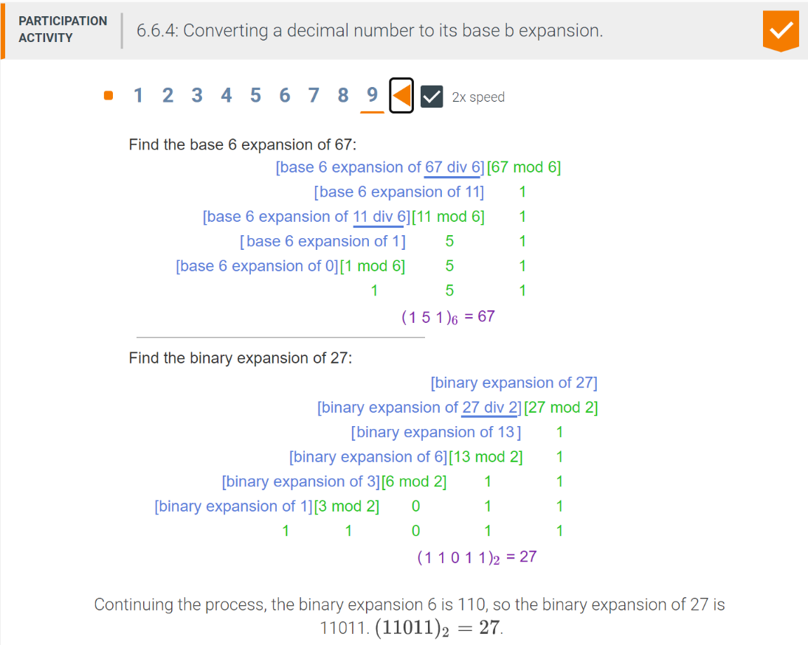
* the number of digits required to expxress the base b expantion of a positive integer n is ⌈logb(n+1)⌉
  + ex. base 2 expansion of 13 is
  + ⌈log2(13 + 1)⌉ = ⌈log2(14)⌉ = ⌈3.8⌉ = 4

Fast exponentiation

* Convert the exponent into binary expansion
* 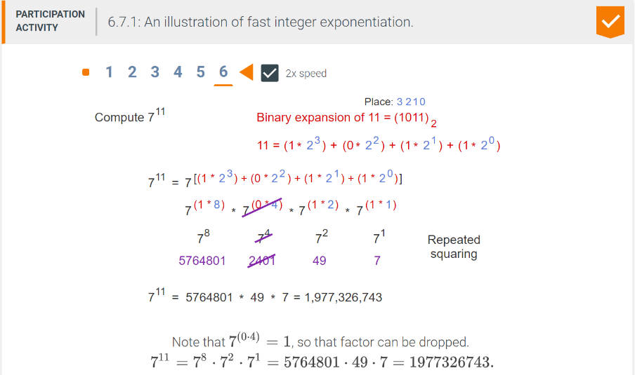
* 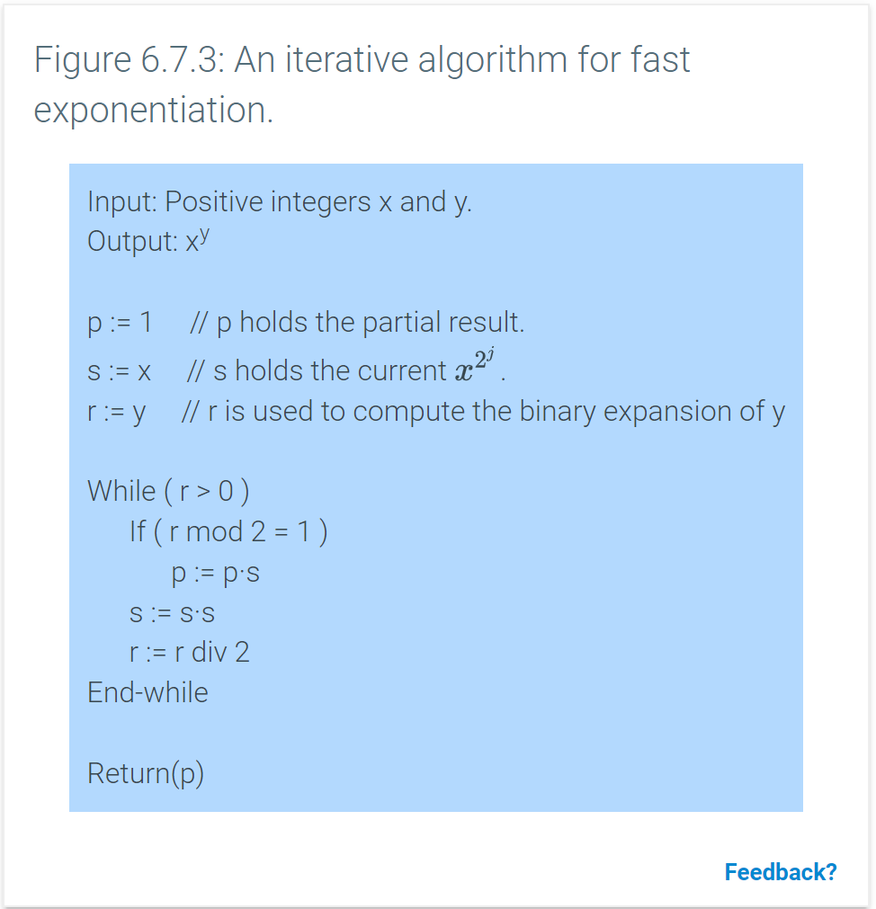

Iterative algorithm

* uses a loop to accomplish repeated operations in contrast with a recursive algorithm which uses recursion
* 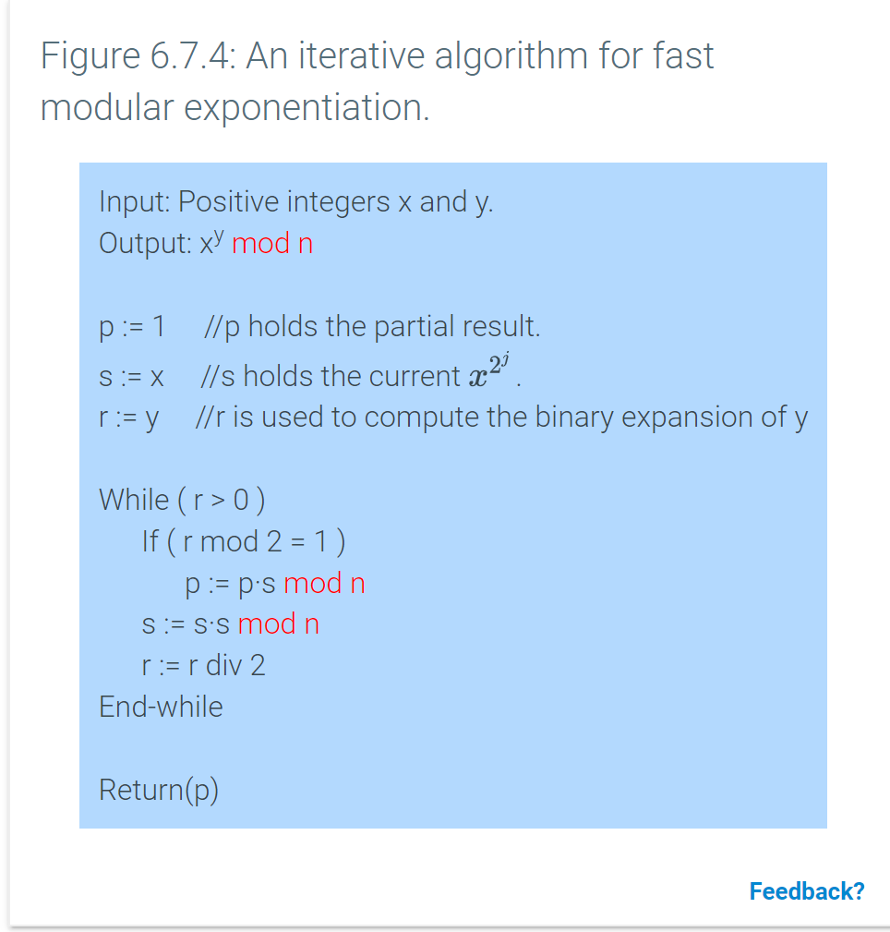

Introduction to cryptography

* Is the science of protecting and authenticating data and communication
* messages are converted into numbers sent to receiver then converted back into letters

Encryption and decryption functions

* integer plaintext m as input
* ciphertext c as output
* given ciphertext c, the decryption process must produce the unique plaintext m whose encryption is c
* Suppose that the set of all possible plaintexts comes from a set M, a subset of the integers. Encryption is a function whose domain is M and whose range is C, the set of all ciphertexts.
* encryption
  + c = (m + k) mod N
* decryption
  + m = (c – k) mod N

sequence

* function in which the domain is a set of consecutive integers
* gk for the function rather than g(k), terminology
* {gk} denoted for entire sequence
* gk is used to denote a single term in the sequence
* finite sequence
  + finite domain
  + initial index m
  + final index n
  + n ≥ m
  + am is the initial term and an is the final term
* infinite sequence
  + infinite domain
  + initial index m
  + sequence is defined for all indices k such that k ≥ m
* explicit formula
  + gk = xk for k ≥ m

Geometric sequence

* is a sequence of real numbers where each term after the initial term is found by taking the previous term and multiplying by a fixed number called the common ratio
* can be either finite or infinite

Arithemetic sequence

* is a sequence of real numbers where each term after the initial term is found by taking the previous term and adding a fixed number called the common difference
* can be either finite or infinite

Recurrence relations

* a rule that defines a term an as a function of previous terms in the sequence

Fibonacci sequence

* fn = fn-1 + fn-2 for n ≥ 2

Dynamical system

* a system that changes over time
* the state of the system at any point is determined by a set of well defined rules that depend on the past states of the system
* discrete time dynamical system
  + time is divided into discrete time intervals and the state of the system stays fixed within each time interval

Summations

* summation notation
  + is used to express the sum of terms in a numerical sequence
  + $\sum_{i-s}^{t}{}$ ai = as + as + 1 + … + at
  + variable i is called the index of the summation
  + value s is the lower limit
  + value t is the upper limit
  + sigma is used to denote that fact that terms are to be added together
* 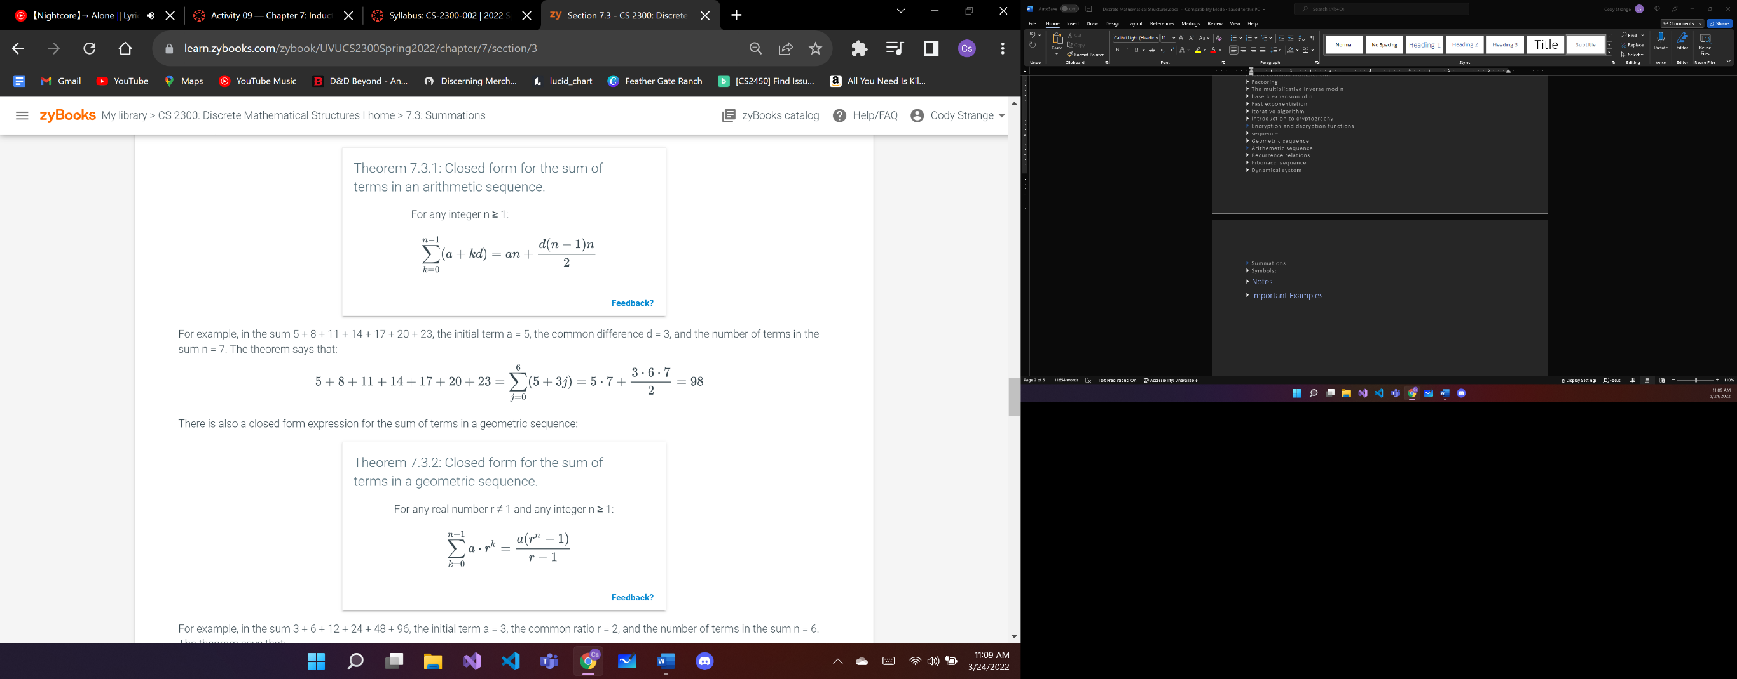

Induction

* base case
  + establishes that the theorem is true for the first value in the sequence
* inductive step
  + establishes that if the theorem is true for k, then the theorem also holdes for k + 1

principle of mathematical induction

* if the base case for n =1 is true and inductive step is true, then the theorem holds for all positive integers

basis

* explicitly states that one or more specific elements are int the set

recursive rule

* shows how to construct additional elements in the set from elements already known to be in the set
* often multiple recursive rules

exclusion statements

* states that an element is in the set only if it is given in the basis or can be constructed by applying the recursive rules repeatedly to elements given in the basis

Time complexity with recursion

* use the recursive function T(n) to figure out the time complexity of the recursive function F(n)
* initial value of T(n)
  + is the number of operations performed during the base case
  + T(0)
* Recurrence relation
  + For n ≥ 1, the value of T(n) is defined by a recurrence relation that includes the running time for the recursive calls + the additional operations performed outside the recursive calls
* ex.
  + T(n-1) + 5

product rule

* provides a way to count sequences
* Let A1, A2,…,An be finite sets. Then, |A1 x A2 x … x An| = |A1| * |A2| * … * |An|

alphabet

* + a set of characters
 $\sum^{n}{}$

 + is the set of all strings of length n whose characters come from the set
  + {}n
* in a set * represents all options in the set
  + when counting each * is equal to the number of options it represents

sum rule

* multiple choices but only one selection is made
* Consider n sets, A1, A2,…,An. If the sets are mutually disjoint, then |A1 U A2 U … U An| = |A1| + |A2| + … + |An|

bijection rule

* if there is a bijection from one set to another then the two sets have the same cardinality
* bijection
  + A function f from a set S to a set T if and only if f has a well defined inverse
* inverse
  + inverse of a function f that maps set S to set T is a function g that maps T to S such that for every s∈S and every t∈T, f(s)=t, and only g(t) = s
  + if a function has an inverse it is denoted by f-1

k-to-1 rule

* Let X and Y be finite sets. The function f:X→Y is a k-to-1 correspondence if for every y ∈ Y, there are exactly k different x ∈ X such that f(x) = y.
* Suppose there is a k-to-1 correspondence from a finite set A to a finite set B. Then |B| = |A|/k.

generalized product rule

* says that in selecting an item from a set, if the number of choices at each step does not depend on previous choices made, then the number of items in the set is the product of the number of choices

r-permutation

* a sequence of items with no repetitions, all taken from the same set
* order matters
* P(n,r) = n! / (n-r)!
* r = items
* n = choices for the items to select

permutation

* n!
* order doesn’t not matter

r-subset

* subset of size r
* order matters
* (…)

r-combination

* r-subset
* order doesn’t matter
* {…}

k-to-1 rule to map r-permutations to r-subsets

* P(n,r) / r!
* r-permuations = r-subsets * r!

Counting subsets



identity

* an equation that holds for all values for which the expressions in the equation are well defined
* C(n,r) = C(n,r-n)
  + for all non-negative integers
  + there is a bijection between r-subsets of S and (n - r)-subsets of S
    - each r-subset X of S corresponds uniquely to a subset of (n - r) elements consisting of the elements that are not in X.

Counting by complement

* is a technique for counting the number of elements in a set S that have a property by counting the total number of elements in S and subtracting the number of elements in S that do not have the property
* |P| = |S| - |_P_|

Permutations with repetitions

* is an ordering of a set of items in which some of the items may be identical to each other
* multiply *n* amount of C(n,r) against eachother where *n* is the number of unique items in the set
* n!/n1!n2!...nk!

Rules for encoding a selection of n objects from m varieties

* Written out in a binary string
* 0’s represent every item of a single type
* 1’s represent spacers between types
* same formula as counting subsets except r = r -1 and n = n + r

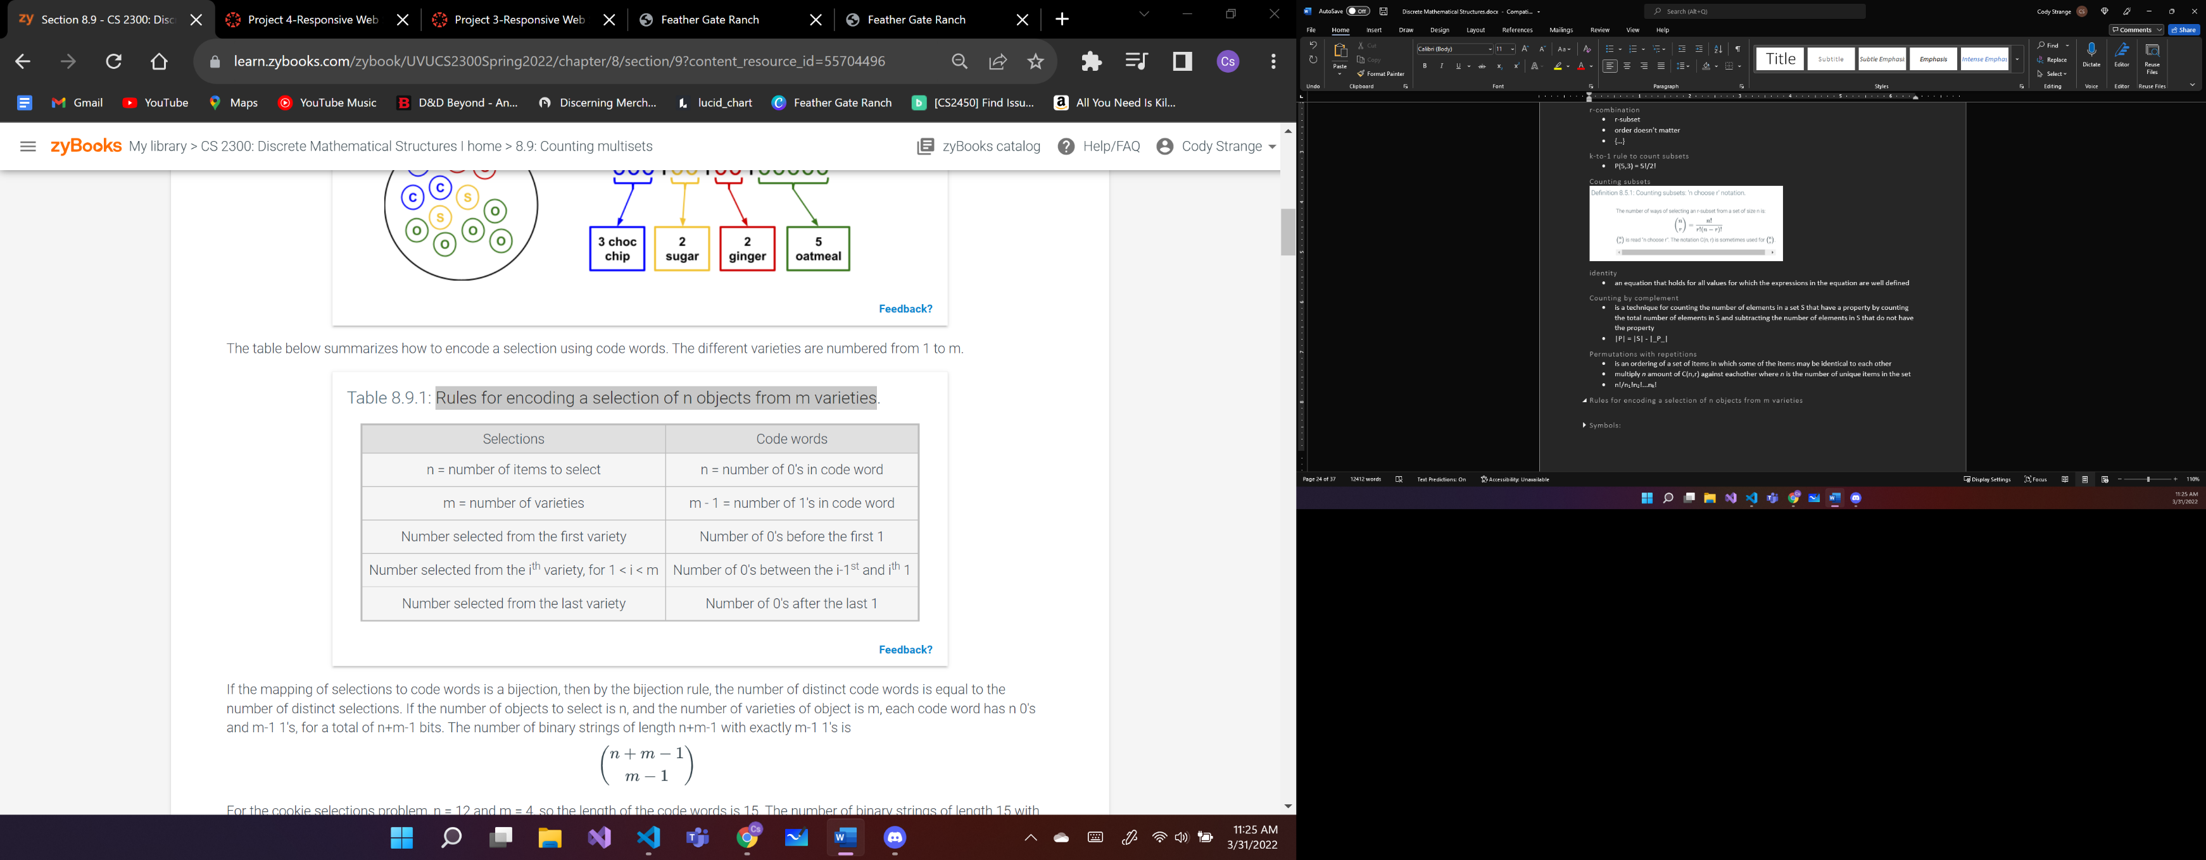

indistinguishable

* A set of identical items
* it is impossible to distinguish one of the items from another

distinguishable

* a set of different or distinct items
* it is possible to distinguish one of the items from the others

balls-in-bins algorithms

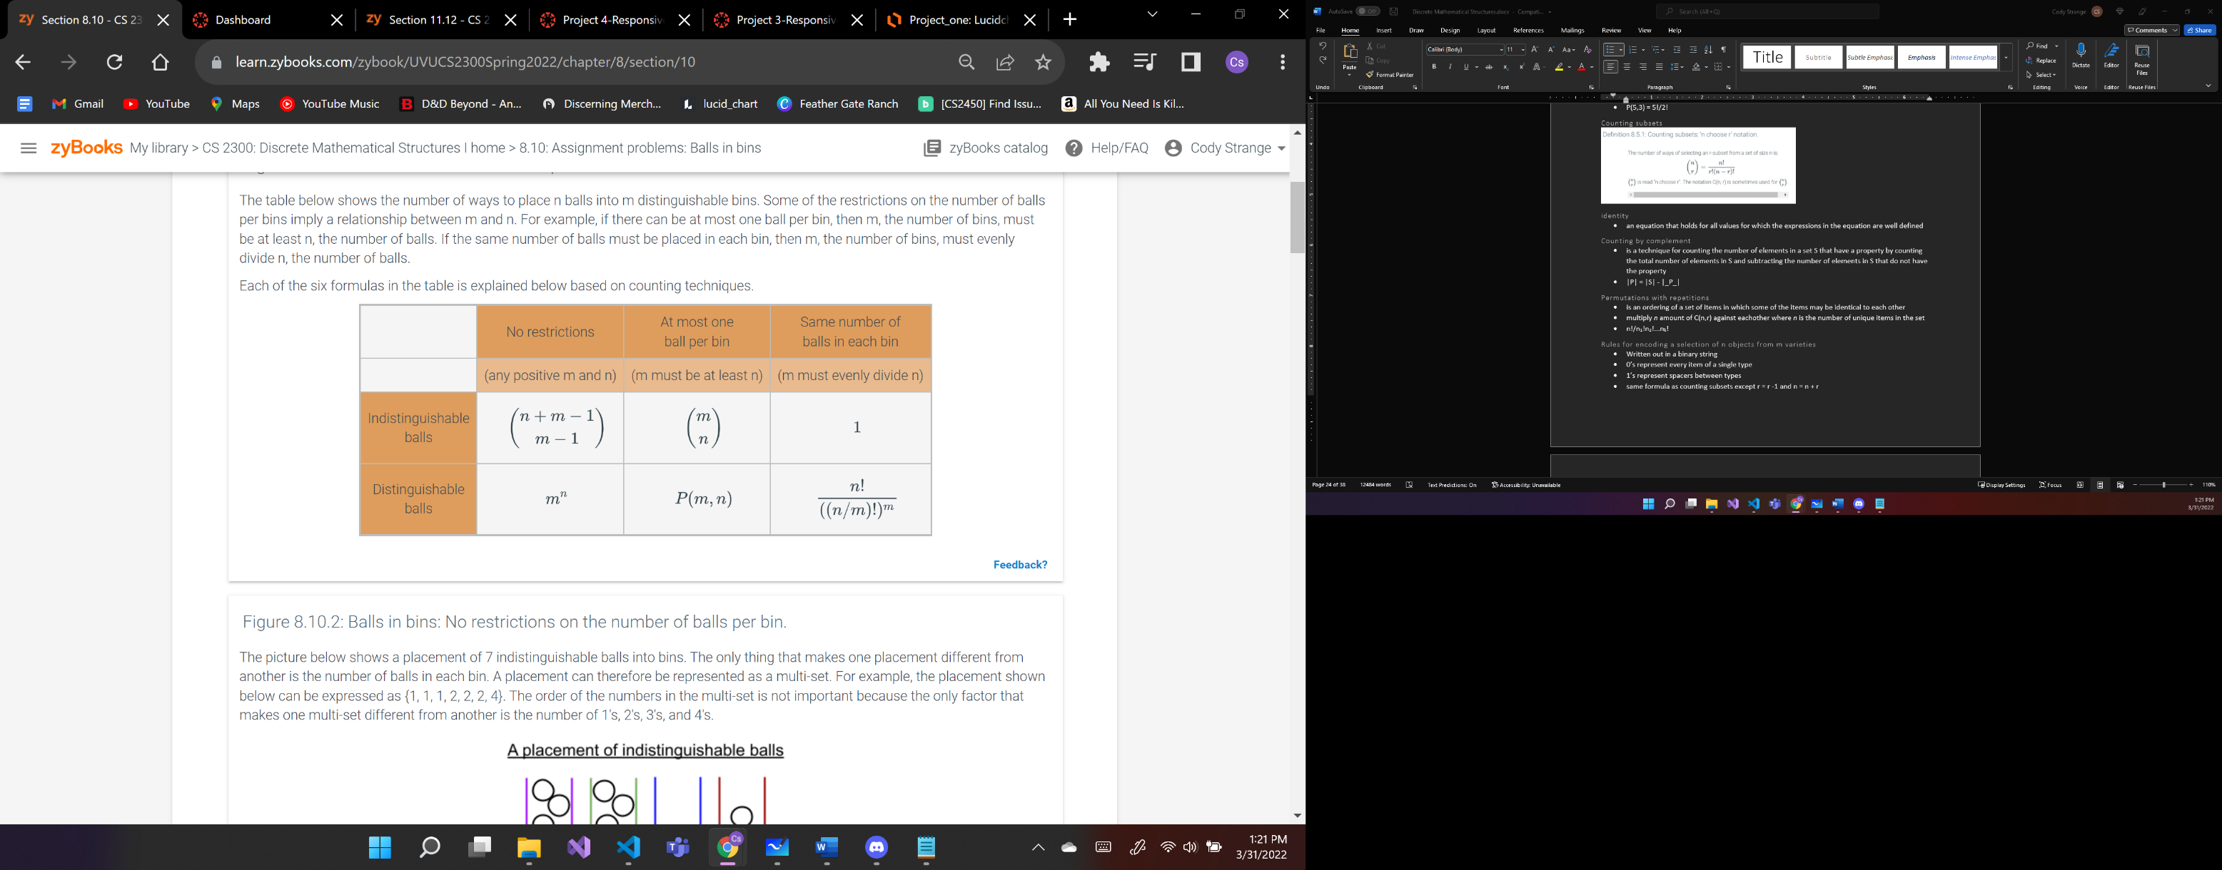

Inclusion-exclusion principle

* a technique fro determining the cardinality of the union of sets that uses the cardinatlity of each individual set as well as the cardinality of their intersections
* |B U R| = |B| + |R| - |B ∩R|
* with three sets
  + |A| + |B| + |C| - |A∩B| - |B∩C| - |A ∩ C| + |A ∩ B ∩ C|

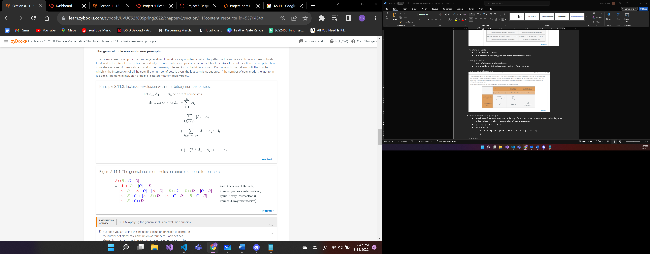

* 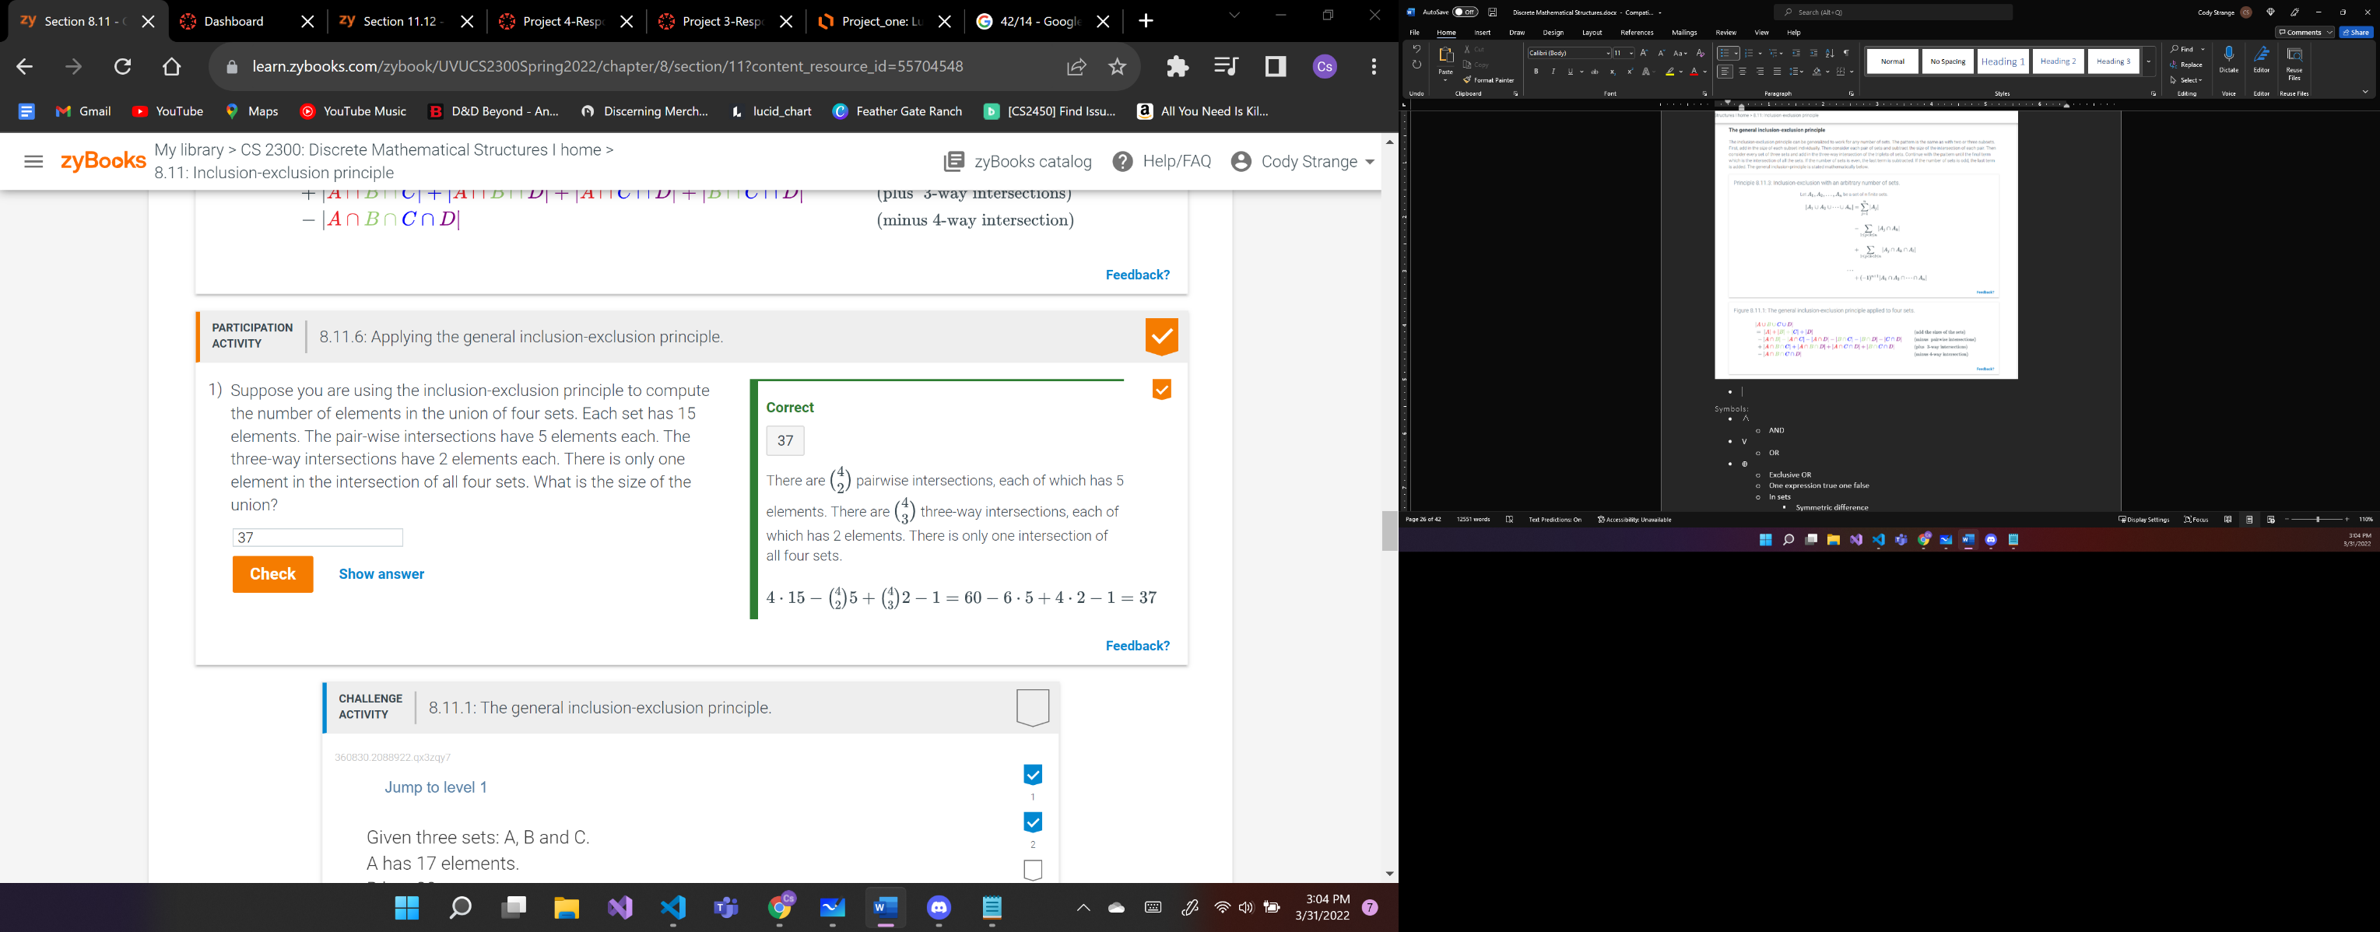

mutually disjoint

* a collection of sets that the intersection of every pair of sets in the collection is empty
* if we apply the principle of inclusion-exclusion to determine the union of a collection of mutually disjoint sets, then all the terms with intersections are zero
* for a collection of mutually disjoint set, the cardinality of the union of the sets is just equal to the sum of the cardinality of each of the individual set

Lexicographic order

* a way of ordering n-tuples in which two n-tuples are compared according to the first entry where they differ
* consider two different n-tuples (p1, p2, …, pn) and (q1, q2, …, qn)
  + to determine which n-tuple is smaller, the n-tuples are scanned from left to right to find the first index where they differ

Generating permutations

* permutation of the set {1,2,…,n} is an ordered n-tuple in which each number in the set appears exactly once in any order
* lexicographic order
  + first perumation is (1,2,…,n-1,n)
  + last perumataion is (n,n-1,…,2,1)
  + each consecutive perumation is larger than the last, while being as small as possible

Generating r-subsets of a set

* sort the sets first then compare by first entry where they differ
* lexicographic order
  + first subset is {1,2,…,r-1,r}
  + last subset is {n-r+1,…,n-1,n}

Combinatorial identities

* C(n,k) = C(n,n-k)

Binomial Theorm

* (a+b)3 = a3 + 3a2b + 3ab2 + b3
* The coefficient of akbn-k is C(n,k)

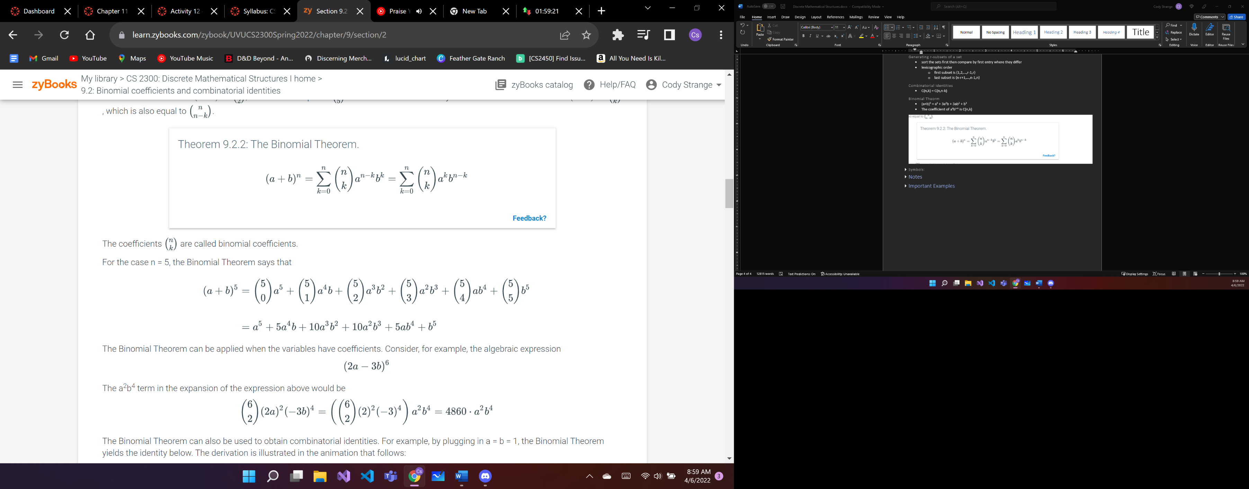

Pigeonhole principle

* a mathematical tool used to establish that repetitions are guaranteed to occur incertain sets and sequences
* if n+1 pigeons are placed in n boxes, then there must be at least one box with more than one pigeon

Generalized Pigeonhole principle

* ⌈n/k⌉
* n = k(b-1) + 1

Undirected graph

* Consists of a pair of sets (V,E)
  + V is a set of vertices
  + E is a set of edges
* Is finite if the set is finite
* single element V is called a vertex
  + represented by a dot with a label
* each edge in E is a set of two vertices from V
  + is drawn as a line connecting the two vertices

Parallel edges

* multiple edges between the same pair of vertices

Self loop

* an edge between a vertex and itself

Simple graph

* a graph with no parallel edges or self-loops

Adjacent

* two vertices that are connected by an edge

Endpoints

* the two vertices that are at the either end of an edge

Neighbor

* similar to adjacent

Degree

* the number of neighbors a vertex has

Total degree

* is the sum of the degrees of all of the vertices

Regular graph

* all vertices have the same degree

d-regular graph

* all vertices have degree d

Subgraph

* A graph H = (VH, EH) is a subgraph of a graph G = (VG, EG) if VH ⊆ VG and EH ⊆ EG. Note that any graph G is a subgraph of itself. The diagram below shows a subgraph H of the graph G:

Calculating degree of graph

* Degree = Edges * 2

Common graphs in graph theory



Adjacency list representation

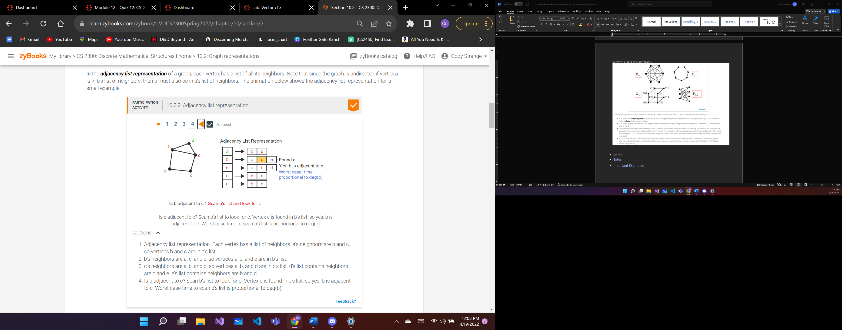

Matrix representation for graphs



Isomorphic

* Two graphs that have a correspondence between the vertex sets of each graph such that there is an edge between two vertices of one gprah if and only if there is an edge between the corresponding vertices of the second graph
* The two graphs can change the labels so that they are identical
* In order to check compare
  + Degree sequence
  + vertices
  + edges

Degree sequence

* The degree sequence of a graph is a list of degrees of all of the vertices in non-increasing order
* Non-increasing order means that each number is less than or equal to the preceding number in the sequence

Connectivity

* Showing that a graph is k-edge-connected involves showing that removing any subset of k - 1 edges leaves the graph connected. If a graph has m edges, there are C(m,k-1) subsets with k - 1 edges. For large k, exhaustively searching all subsets would be infeasible. Fortunately, there are more efficient ways to determine the edge connectivity and vertex connectivity of a graph. The theorem below shows that the minimum degree of any vertex (which is easy to compute) is at least an upper bound for both the edge and vertex connectivity of a graph.
* If the graph is a complete graph denoted kn then the connectivity is n – 1
* cycle graphs connectivity is always two
* 0 ≤ K(G) ≤ n -1
  + K(G) = connectivity
  + n = vertex total

Tree

* an undirected graph that is connected and has no cycles
* There is exactly one way to travel between every pair of vertices by a path
* edge of a tree equals the vertices - 1

Free tree

* there is no particular organization of the vertices
* leaf
  + a vertex of degree 1
* if a vertex’s degree is at least two then it is called an internal vertex
* Any free tree with at least two vertices has at least two leaves

Rooted tree

* a vertex is designated as the root
  + remaining vertices are organized according to their distance from the root
* There is a uniwue path between every pair of vertices in a tree

Distance

* distance between two vertices is the number of edges in the shortest path between two vertices

Level

* a vertex’s distance from the root

Height

* the heighest level of any vertex

Traversal

* Inorder: LMR
* Preorder: MLR
* Postorder: LRM

Spanning Tree

* A spanning tree of a connected graph G is a subgraph of G which contains all the vertices in G and is a tree

Depth-First Search

* Start at a single vertex and incrementally build a connected tree by adding edges and vertices
* Resulting tree is a rooted tree at the start vertex
* Tends to produce trees with longer paths from the start vertex
* Search going down to the furthest level of the tree at a time

Breadth-First Search

* Start at a single vertex and incrementally build a connected tree by adding edges and vertices
* Resulting tree is a rooted tree at the start vertex
* Search all of a nodes children first

Minimum spanning tree

* a minimum spanning tree of a weighted graph, is a spanning tree T of G whose weight is no larger than any other spannin tree of G

Terminology related to rooted trees



Canonical order

* The natural way to enumerate a set
* strings are grouped together according to length
* the groups are arranged in increasing length, and the strings within each group are alphabetized

Symbols

* ∧
  + AND
* V
  + OR
* Ꚛ
  + Exclusive OR
  + One expression true one false
  + In sets
    - Symmetric difference
    - is the set of elements that are a member of exactly one of A and B, but not both
* ¬
  + NOT
* →
  + Conditional operator
  + IF___THEN___
  + P→Q
    - P = hypothesis
    - Q = conclusion
    - False if and only if P=T and Q=F
* ∀
  + Universal quantifier
  + ⱯxP(x)
    - Universally quantified statement
    - Every x in P(x) is true
* ∃
  + Existential quantifier
  + ⱻxP(x)
    - Existentially quantified statement
    - There exists an x, such that P(x) is true
* ↔
  + Biconditional operator
    - P=Q
* ≡
  + Logically Equivalent
    - Two proposition share truth tables
* ∴
  + Therefore
* |
  + Divides
* ∤
  + Does not Divide
* ∎
  + End of proof
* ∈
  + Used to indicate that an element is in a set
* ∌
  + Used to indicate that an element is not in a set
* ∅
  + Empty set
* | |
  + Cardinality of a finite set
  + number of distinct elements in a set
  + |P(A)| = 2x, where x is elements in P(A)
* …
  + Used to denote a long(possibly) infinite sequence of numbers.
  + B = {1, 3, 5, … , 99}
  + Pattern of set should be clear to readers
* +
  + Superscript +
  + is used to indicate the positive elements of a particular set
* -
  + Superscript –
  + is used to indicate the negative elements of a particular set
* *U*
  + universal set
  + is a set that contains all elements mentioned in a particular context
  + ex. in a discussion about real numbers, it would be understood all numbers in the discussion would be real numbers
* ⊆
  + A is a subset of B
    - A ⊆ B
* ⊈
  + A is not a subset of B
    - A ⊈ B
* ⊂
  + Subset is one way between two variables
  + A is a subset of B but B is not a subset of A
  + Proper subset
* ∩
  + Intersection
  + A∩B
    - elements that both A and B share
    - AND
* ∪
  + Union
  + A∪B
    - elements that are A or B
    - OR
* _A_
  + complement
  + State at the start of each HW what this means
  + A is just a variable
  + is the set of all elements in *U* that are not elements of A
  + *U* – A
* ⌊ ⌋
  + floor(x) = ⌊x⌋
* ⌈ ⌉
  + ceiling(x) = ⌈x⌉
* O
  + f = O(g)
    - f is oh of g
    - the function f(n) is less than or equal to g(n), if constant factors are omitted and small values for n are ignored
    - IT IS BIG O’NOTATION
* Ω
  + f = Ω(g)
    - f is omega of g
* _≺_
  + a _≺_ b
    - aRb
    - a is at most b
  + poset
* ≺
  + a ≺ b
  + aRb
  + a is less than b
* ~
  + a ~ b
    - aRb
    - a is equivalent to b

# Notes

Order of Operations:

* 1. Not
* 2. AND
* 3. OR

Laws of Propositional Logic

|  |  |  |
| --- | --- | --- |
| Idempotent laws: | p ∨ p ≡ p | p ∧ p ≡ p |
| Associative laws: | ( p ∨ q ) ∨ r ≡ p ∨ ( q ∨ r ) | ( p ∧ q ) ∧ r ≡ p ∧ ( q ∧ r ) |
| Commutative laws: | p ∨ q ≡ q ∨ p | p ∧ q ≡ q ∧ p |
| Distributive laws: | p ∨ ( q ∧ r ) ≡ ( p ∨ q ) ∧ ( p ∨ r ) | p ∧ ( q ∨ r ) ≡ ( p ∧ q ) ∨ ( p ∧ r ) |
| Identity laws: | p ∨ F ≡ p | p ∧ T ≡ p |
| Domination laws: | p ∧ F ≡ F | p ∨ T ≡ T |
| Double negation law: | ¬¬p ≡ p |  |
| Complement laws: | p ∧ ¬p ≡ F ¬T ≡ F | p ∨ ¬p ≡ T ¬F ≡ T |
| De Morgan's laws: | ¬( p ∨ q ) ≡ ¬p ∧ ¬q | ¬( p ∧ q ) ≡ ¬p ∨ ¬q |
| Absorption laws: | p ∨ (p ∧ q) ≡ p | p ∧ (p ∨ q) ≡ p |
| Conditional identities: | p → q ≡ ¬p ∨ q | p ↔ q ≡ ( p → q ) ∧ ( q → p ) |

Rule of Inference:

* Proven to be valid

|  |  |
| --- | --- |
| Rule of inference | Name |
| p p → q∴ q | Modus ponens |
| ¬q p → q∴ ¬p | Modus tollens |
| p∴ p ∨ q | Addition |
| p ∧ q∴ p | Simplification |
| p q∴ p ∧ q | Conjunction |
| p → q q → r∴ p → r | Hypothetical syllogism |
| p ∨ q ¬p∴ q | Disjunctive syllogism |
| p ∨ q ¬p ∨ r∴ q ∨ r | Resolution |

Rule of Inference for quantified statements:

|  |  |  |
| --- | --- | --- |
| Rule of Inference | Name | Example |
| c is an element (arbitrary or particular) ∀x P(x) ∴ P(c) | Universal instantiation | Sam is a student in the class. Every student in the class completed the assignment. Therefore, Sam completed his assignment. |
| c is an arbitrary element P(c)         ∴ ∀x P(x) | Universal generalization | Let c be an arbitrary integer. c ≤ c2 Therefore, every integer is less than or equal to its square. |
| ∃x P(x) ∴ (c is a particular element) ∧ P(c) | Existential instantiation* | There is an integer that is equal to its square. Therefore, c2 = c, for some integer c. |
| c is an element (arbitrary or particular) P(c)         ∴ ∃x P(x) | Existential generalization | Sam is a particular student in the class. Sam completed the assignment. Therefore, there is a student in the class who completed the assignment. |

Common keywords and phrases in proofs

* Thus
  + n and m are integers. Therefore, n+m is also an integer.
  + n is a positive integer. Thus, n ≥ 1.
  + Other words that serve the same purpose are "it follows that", "then", "hence".
* Therefore
  + n and m are integers. Therefore, n+m is also an integer.
  + n is a positive integer. Thus, n ≥ 1.
  + Other words that serve the same purpose are "it follows that", "then", "hence".
* Let
  + New variable names are often introduced with the word "let". For example, "Let x be a positive integer".
* Suppose
  + The word "suppose" can also be used to introduce a new variable. For example: "Suppose that x is a positive integer". Suppose is also used to introduce a new assumption, as in: "Suppose that x is odd", assuming that x has already been introduced as an integer earlier in the proof.
* Since
  + If a statement depends on a fact that appeared earlier in the proof or in the assumptions of the theorem, it can be helpful to remind the reader of that fact before the statement. The phrase "because we know that" can serve the same purpose. For example, assuming that the facts x > 0 and y > z have been established earlier, a proof could say:
    - "Since x > 0 and y > z, then xy > xz."
    - "Because we know that x > 0 and y > z, then xy > xz."
* By definition
  + A fact that is known because of a definition, can be started with the phrase "By definition". For example: "The integer m is even. By definition, m = 2k for some integer k."
* By assumption
  + A fact that is known because of an assumption, can be started with the phrase "By assumption". For example: "By assumption, x is positive. Therefore x >0."
* In other words
  + Sometimes it is useful to rephrase a statement in a more specific way. The phrase "in other words" is useful in this context. For example: "We must show that the average of x and y is positive. In other words, we must show that (x+y)/2 > 0."
* Gives
  + Sometimes a proof is clearer if even an algebraic step is justified. The words "gives" and "yields" are useful to say that one equation or inequality follows from another.
    - Multiplying both sides of the inequality x > y by 2, gives 2x > 2y.
    - Substituting m = 2k into m2 yields (2k)2
    - Since z > 0, we can multiply both sides of the inequality x > y by z to get xz > yz.
* Yields
  + Sometimes a proof is clearer if even an algebraic step is justified. The words "gives" and "yields" are useful to say that one equation or inequality follows from another.
    - Multiplying both sides of the inequality x > y by 2, gives 2x > 2y.
    - Substituting m = 2k into m2 yields (2k)2
    - Since z > 0, we can multiply both sides of the inequality x > y by z to get xz > yz.

Best practices in writing proofs

* Indicate when the proof starts and ends
* Write proofs in complete sentences
* Give the reader a roadmap of what has been shown, what is assumed, and where the proof is going
* Introduce each variable when the variable is used for the first time
* A block of equations should be introduced with English text and each step that does not follow from algebra should be justified

Proof by contrapositive

* Proves p → c by showing ¬c → ¬p
* Sometimes is easier to prove by contrapositive than by direct proof

Proof by contradiction

* Starts by assuming that the theorem is false and then shows that some logical inconsistency arises as a result of the assumption
* If the assumption that the theorem is false leads to a conclusion which cannot be true, then the theorem must be true
* Indirect proof
* Begins with the assumption ¬t leads to a conclusion r ꓥ ¬r

Proof by cases

* Breaks the domain for the variable x into different classes and gives a different proof for each class
* The proof for each class is called a case
* Every value in the domain must be included in at least on class
* Cases are numbered and each case begins with “Case n:”, where n is the number of that case
* Without loss of generality
  + Abbreviated WLOG
  + Is used in mathematical proofs to narrow the scope of a proof to one special case in situations when the proof can be easily adapted to apply to the general case
  + When two cases are similar enough you can pretty much say, “Without loss of generality”

Steps to writing direct proof

1. Define terms
2. State Theorem Formally
3. Playing around
4. Prove Theorem
   1. Start with assumptions
      1. Suppose *m* and *n* are even integers
   2. Apply definitions
      1. As *m, n, are even,* ⱻ*r* and ⱻ*s* so that *m* = 2*r* and *n* = 2*s*
   3. Manipulations
      1. Then, *mn* = (2*r*)(2*s*) by substitution
      2. *mn* = 2(2rs) by algebra
      3. Let t = 2rs, and note it is an integer
      4. Hence, ⱻt so that *mn*=2t
   4. Get to conclusion
      1. Thus *mn* is even ▪
   5. Additional notes
      1. First and last lines of Proof should combine to make the theorem
      2. Apply definitions before and after Manipulations
      3. Manipulations == algebra

Common mathematical sets

|  |  |  |
| --- | --- | --- |
| Set | Symbol | Examples of elements |
| ***N*** is the set of ***natural numbers***, which includes all integers greater than or equal to 0. | **N** | 0, 1, 2, … |
| ***Z*** is the set of all integers. | **Z** | …, -2, -1, 0, 1, 2, … |
| ***Q*** is the set of ***rational numbers***, which includes all real numbers that can be expressed as a/b, where a and b are integers and b ≠ 0. | **Q** | 0, 1/2, 5.23, -5/3 |
| ***R*** is the set of real numbers. | **R** | 0, 1/2 |

Set identities

|  |  |  |
| --- | --- | --- |
| Name | Identities | |
| Idempotent laws | A ∪ A = A | A ∩ A = A |
| Associative laws | (A ∪ B) ∪ C = A ∪ (B ∪ C) | (A ∩ B) ∩ C = A ∩ (B ∩ C) |
| Commutative laws | A ∪ B = B ∪ A | A ∩ B = B ∩ A |
| Distributive laws | A ∪ (B ∩ C) = (A ∪ B) ∩ (A ∪ C) | A ∩ (B ∪ C) = (A ∩ B) ∪ (A ∩ C) |
| Identity laws | A ∪ ∅ = A | A ∩ *U* = A |
| Domination laws | A ∩ ∅ = ∅ | A ∪ *U* = *U* |
| Double complement law | _ _A_ _=A | |
| Complement laws | A ∩ _A_ = ∅ U = ∅ | A ∪ _A_ = *U* ∅ = U |
| De Morgan's laws | _A ∪ B_ = _A_ ∩ _B_ | _A ∩ B_ = _A_ ∪ _B_ |
| Absorption laws | A ∪ (A ∩ B) = A | A ∩ (A ∪ B) = A |
|  |  |  |

Properties of exponents

* for any positive real numbers b, c, and any real numbers x, and y, the following equilities are always true:
  + bxby = bx+y
  + (bx)y = bxy
  + bx/by = bx-y
  + (bc)x = bxcx
* Exponential function is one-to-one and onto therefore it has an inverse
  + Logarithm function

Properties of logarithms

* For any positive numbers b, c, x, and y, such that b ≠ 1 and c ≠ 1, the following equalities are always true:
* logb(xy) = logbx + logby
* logb(x/y) = logbx – logby
* logb(xy) = ylogbx
* logcx = logbx / logbc

# Important Examples

Express: “Exactly one person was late to the meeting”

* L(x) = x was late to the meeting
* ⱻxL(x) ꓥ Ɐy(x ≠ y) → ¬L(x)
  + someone was late to meeting AND if person(x) is not person(y) then person(x) was not late
  + Exactly one person was late to the meeting

Proof of the Graph Power Thoerem

Proof 5.5.1: Proof of the Graph Power Theorem.

**Theorem:** Let G be a directed graph. Let u and v be any two vertices in G. There is an edge from u to v in Gk if and only if there is a walk of length k from u to v in G.

**Proof.**

By induction on k.

**Base case:** k = 1. G1 = G, by definition. Moreover an edge (u, v) is a walk ⟨u, v⟩ of length 1. Therefore, there is an edge (u, v) in G1 if and only if there is a walk ⟨u, v⟩ of length 1 in G.

**Inductive step:** Prove that for k > 1, if it is true that:

there is an edge (u, v) in Gk-1   ↔   there is a walk from u to v of length k - 1 in G

then it is true that:

there is an edge (u, v) in Gk   ↔   there is a walk from u to v of length k in G

E, Ek-1, and Ek are the edge sets for G, Gk-1, and Gk. By definition, Ek is obtained by composing E and Ek-1: Ek = E ο Ek-1. By definition of composition, there is an edge (u, v) in Gk if and only if there is a vertex x, such that (u, x) is an edge in Gk-1 and (x, v) is an edge in G. By the assumption that the theorem holds for k - 1, there is an edge (u, x) in Gk-1 if and only if there is a walk from u to x of length k - 1 in G. The edge (x, v) in G is a walk of length 1 in G: ⟨x, v⟩.

We have shown that there is an edge (u, v) in Gk if and only if there is a vertex x such that there is a walk of length k-1 from u to x and a walk of length 1 from x to v in G.

It remains to show that there is an x such that there is a walk of length k-1 from u to x and a walk of length 1 from x to v in G if and only if there is a walk of length k in G from u to v. Each direction of the "if and only if" is proven separately.

Suppose that ⟨u, …, x⟩ is a walk of length k-1 and ⟨x, v⟩ is a walk of length 1 in G. The walks ⟨u, … , x⟩ and ⟨x, v⟩ can be put together to form a walk ⟨u, …, x, v⟩. The length of the walk from u to v is the sum of the lengths of walks from u to x and from x to v: (k - 1) + 1 = k.

Now suppose that there is a walk of length k from u to v in G. Let x be the second-to-last vertex reached on the walk: ⟨u, … x, v⟩. Then ⟨u, …, x⟩ must be a walk of length k - 1 from u to x in G and (x, v) must be an edge in G.  ■

Proof 5.6.1: Relationship between the powers of a graph and the powers of its adjacency matrix.

Theorem: Let G be a directed graph with n vertices and let A be the adjacency matrix for G. Then for any k ≥ 1, Ak is the adjacency matrix of Gk, where Boolean addition and multiplication are used to compute Ak.

Proof.

The proof is by induction on k. For the base case, k = 1. By definition G1 = G, and A1 = A is the adjacency matrix for G.

Now assume that Ak-1 is the adjacency matrix for Gk-1, and prove that Ak is the adjacency matrix for Gk. Since Ak-1 is the adjacency matrix for Gk-1, (Ak-1)i,j is 1 if and only if there is a walk in graph G of length k - 1 from vertex i to vertex j. We will show that (Ak)i,j is 1 if and only if there is a walk of length k in G from vertex i to vertex j.

Suppose that (Ak)i,j =1. Since Ak = Ak-1·A, by definition of matrix multiplication,

Since (Ak)i,j = 1, there is at least one x in the range from 1 through n such that (Ak-1)i,x·Ax,j = 1. For that value of x, (Ak-1)i,x = 1 and Ax,j = 1. Since (Ak-1)i,x = 1, by the inductive hypothesis, there is walk of length k-1 from vertex i to vertex x in G. Since Ax,j = 1, there is an edge in G from vertex x to vertex j. The length k-1 walk from i to x, followed by the edge from x to j, results in a walk of length k in G from vertex i to vertex j.

Now suppose that there is a walk of length k in G from vertex i to vertex j. Let x be the second-to-last vertex visited on the walk. There is a walk of length k-1 in G from vertex i to vertex x and an edge in G from vertex x to vertex j. By induction, (Ak-1)i,x = 1 and Ax,j = 1. Therefore, by definition of Boolean matrix multiplication, (Ak)i,j =1. ■

Proof 5.8.1: Strict orders are anti-symmetric.

Proof.

Suppose by contradiction that domain contains two elements, x ≠ y, such that xRy and yRx. Suppose that R is also anti-reflexive and transitive. Since R is transitive, then the fact that xRy and yRx implies that xRx. The fact that xRx contradicts the assumption that R is anti-reflexive. ■

Proof 5.8.2: Directed acyclic graphs and strict orders.

Proof.

If G has a cycle, then there is a path v0,...,vk in G where v0 = vk and k ≥ 1. The existence of the path of length k implies that there is an edge (v0, vk) in Gk. All the edges in Gk are included in G+. Since v0 = vk, the edge is a self-loop, implying that G+ cannot be anti-reflexive. Therefore, G+ is not a strict order.

G+ is by definition transitive, so in order for it not to be a strict order, it must not be anti-reflexive which means that it has a self-loop. Suppose that G+ has a self loop at vertex v. The edge (v, v) must be in Gk for some k ≥ 1. The existence of the edge (v, v) in Gk means that there is a path of length k in G that begins and ends at vertex v. Thus, there is a cycle of length k in G and G is not acyclic. ■

Proof 5.9.1: Structure of equivalence relations.

Proof.

Suppose that x~y. Pick an element z ∈ [y]. It follows that y~z. Since x~y and y~z, it follows from transitivity that x~z, which in turn means that z ∈ [x]. This establishes that any element in [y] must also be in [x]. Since x~y and the relation is symmetric, we know that y~x. The same argument can then be used to show that any element in [x] must also be in [y]. Thus, [x] = [y].

The proof of the second part of the theorem is a proof by contradiction. Suppose that it is not the case that x~y, but there is some z ∈ [x] ∩ [y]. Since z ∈ [x] ∩ [y], it must be the case that x~z and y~z. By symmetry, y~z implies that z~y. Since x~z and z~y, it follows from transitivity that x~y, which contradicts the assumption. ■

Proof 5.9.2: Equivalence relations define a partition.

Proof.

By the definition of an equivalence class, if a ∈ A, then [a] ⊆ A. Since a~a for every a ∈ A, a ∈ [a]. Therefore every element in A is included in at least one set in the partition which implies that the union of all the equivalence classes is the set A. The previous theorem established that if [a] ≠ [b], then [a] ∩ [b] = ∅. Therefore, the set of distinct equivalence classes are pairwise disjoint. A set of sets is pairwise disjoint if the intersection of any pair of the sets is empty. ■

Proof 6.1.1: Divisibility and linear combinations.

Proof.

Since x|y, then y = kx for some integer k. Similarly, since x|z, then z = jx for some integer j. A linear combination of y and z can be expressed as:

sy + tz = s(kx) + t(jx) = (sk + tj)x.

Since sy + tz is an integer multiple of x, then x|(sy + tz). ■

Definition 6.1.2: Integer division definitions.

In the Division Algorithm, the number q is called the quotient and the number r is called the remainder. The operations div and mod produce the quotient and the remainder as a function of n and d.

q = n div d

r = n mod d

Definition 6.1.3: Procedural version of the Division Algorithm

Input: Integers n and d > 0.

Output: q = n div d, and r = n mod d.

Case 1: n ≥ 0. Case 2: n < 0.

q := 0

r := n

While ( r ≥ d )

q := q + 1

r := r - d

End-While q := 0

r := n

While ( r < 0 )

q := q - 1

r := r + d

End-While

Proof 6.2.1: Alternate characterization of congruence mod m

Proof.

First suppose that x ≡ y (mod m). By definition, x mod m = y mod m. We define the variable r to be the value of x mod m = y mod m. Therefore, x = r + km for some integer k and y = r + jm for some integer j. Then

x - y = (r + km) - (r + jm) = (k - j)m

Since (k - j) is an integer, m|(x - y).

Now suppose that m|(x - y). Then (x - y) = tm for some integer t. Let r be the value of x mod m. Then x = r + km for some integer k. The integer y can be expressed as

y = x - (x - y) = (r + km) - tm = r + (k - t)m.

Since r is an integer in the range from 0 to m-1, r is the unique remainder when y is divided by m. Therefore r = y mod m = x mod m, and by definition x ≡ y (mod m). ■

Theorem 6.2.2: Computing arithmetic operations mod m.

Let m be an integer larger than 1. Let x and y be any integers. Then

[(x mod m) + (y mod m)] mod m = [x + y] mod m

[(x mod m)(y mod m)] mod m = [x·y] mod m

Proof.

The definition of the mod function says that x = im + (x mod m) for some integer i. Therefore x mod m is equal to x - im. By setting k = -i, the value of (x mod m) can be expressed as x + km for some integer k. Note that k could be positive, negative or zero. Similarly, y mod m = y + jm for some integer j. Substitute the above expressions into the equation in the theorem.

[(x mod m) + (y mod m)] mod m = [(x + km) + (y + jm)] mod m = [(x + y) + (k + j)m] mod m.

The integers [(x + y) + (k + j)m] and (x + y) differ only by a multiple of m. Therefore they have the same result mod m:

[(x + y) + (k + j)m] mod m = (x + y) mod m

Similarly, when x and y are multiplied:

[(x mod m)·(y mod m)] mod m = [(x + km)·(y + jm)] mod m = [(x·y) + (ky + jx + jkm)m] mod m.

The integers x·y and [(x·y) + (ky + jx + jkm)m] differ only by a multiple of m. Therefore, they have the same result mod m:

[(x·y) + (ky + jx + jkm)m] mod m = (x·y) mod m ■

Proof 6.4.1: Small factors.

If N is composite, there is an integer x greater than 1 that divides N. Define y to be the integer N/x. xy = N and therefore y also divides N. We will show by contradiction that either x or y is at most sqr(N).

Suppose it is not the case that either x or y is at most sqr(N) . Then both x and y are greater than sqr(N). Then xy > sqr(N) * sqr(N) = N

The fact that xy > N contradicts the fact that xy = N. ■

Infnite number of primes

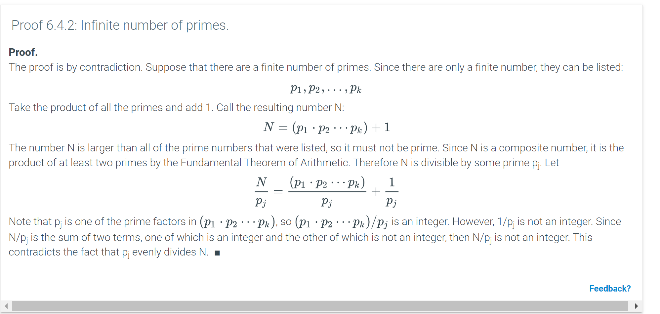

Proof 6.5.1: GCD Theorem.

Proof.

We will prove that a number k is a factor of both x and y if and only if it is a factor of both x and (y mod x). Then the largest common divisor of x and y is also the largest common divisor of x and (y mod x).

Suppose that k is a factor of x and y. Then k is also a factor of any linear combination of x and y. If r = y mod x, then y = r +jx for some integer j. Therefore r = y - jx which means that r is a linear combination of x and y and k divides r.

Now suppose that k divides x and (y mod x). Again r = (y mod x) can be expressed as y - jx for some integer j. y can then be expressed as a linear combination of x and r:

r + jx = (y - jx) + jx = y

Therefore, k also divides y. ■

Converting between binary, octacl, and hex

<https://youtu.be/vAKiTsEKEQM>

Proving an inequality by induction

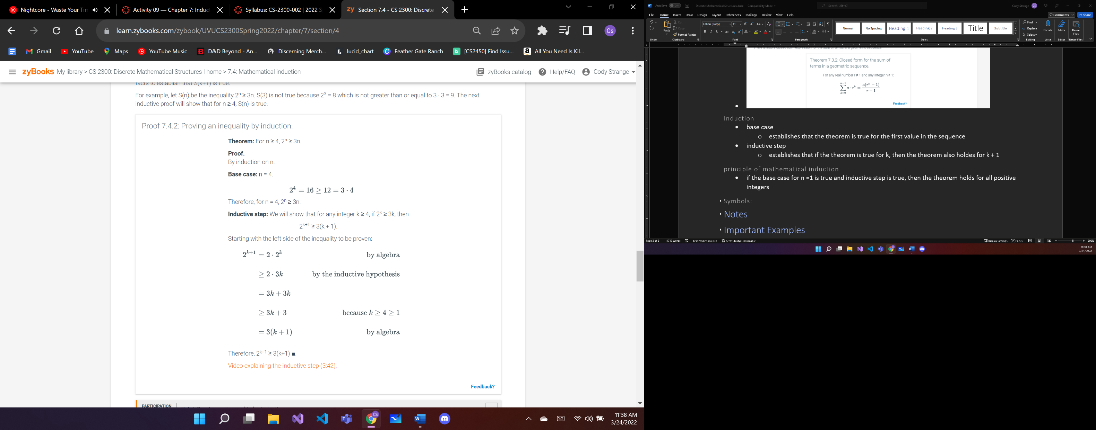

Divisibility proof by induction

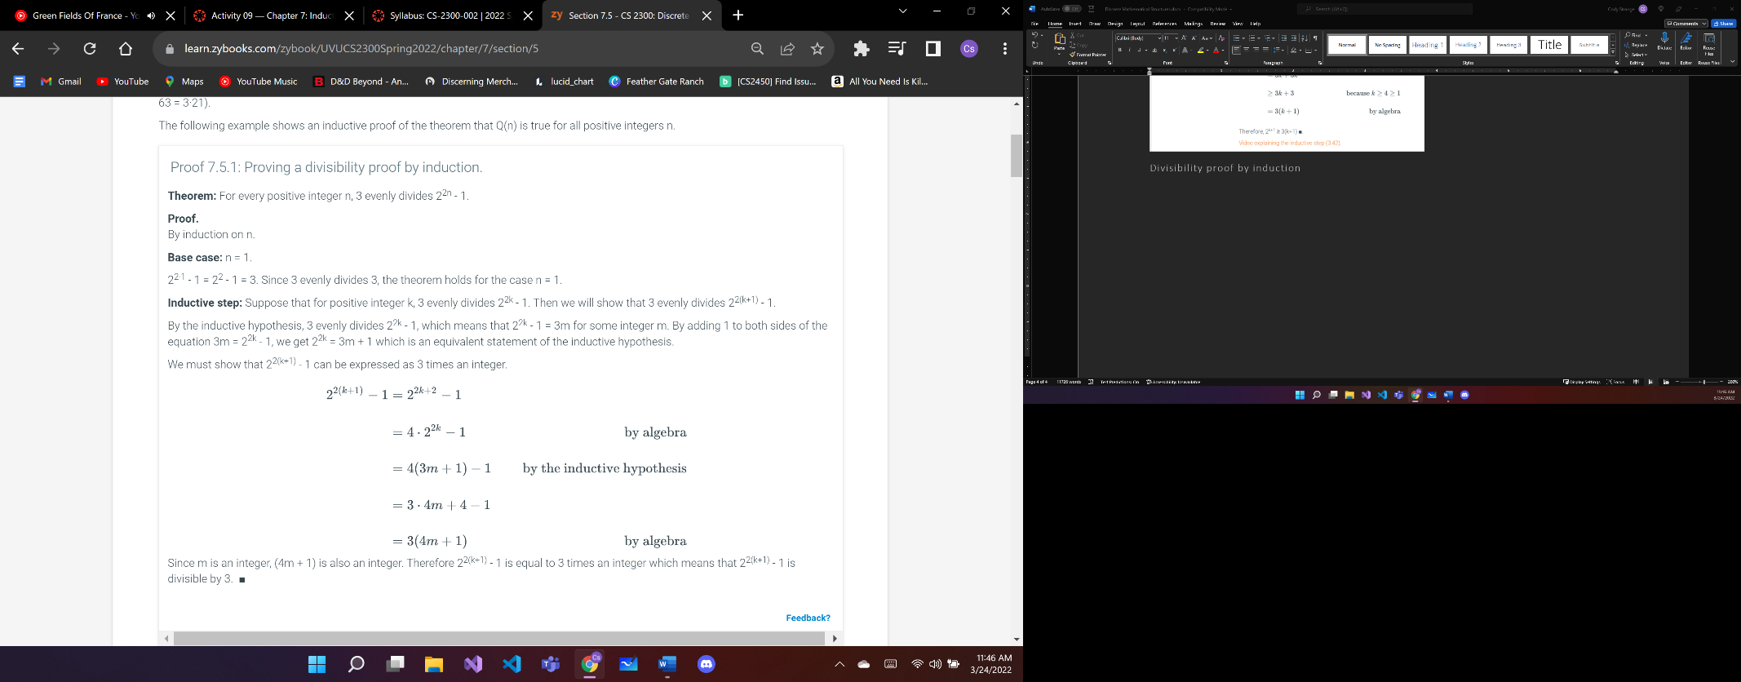

Proof 7.7.1: A complete proof using a loop invariant

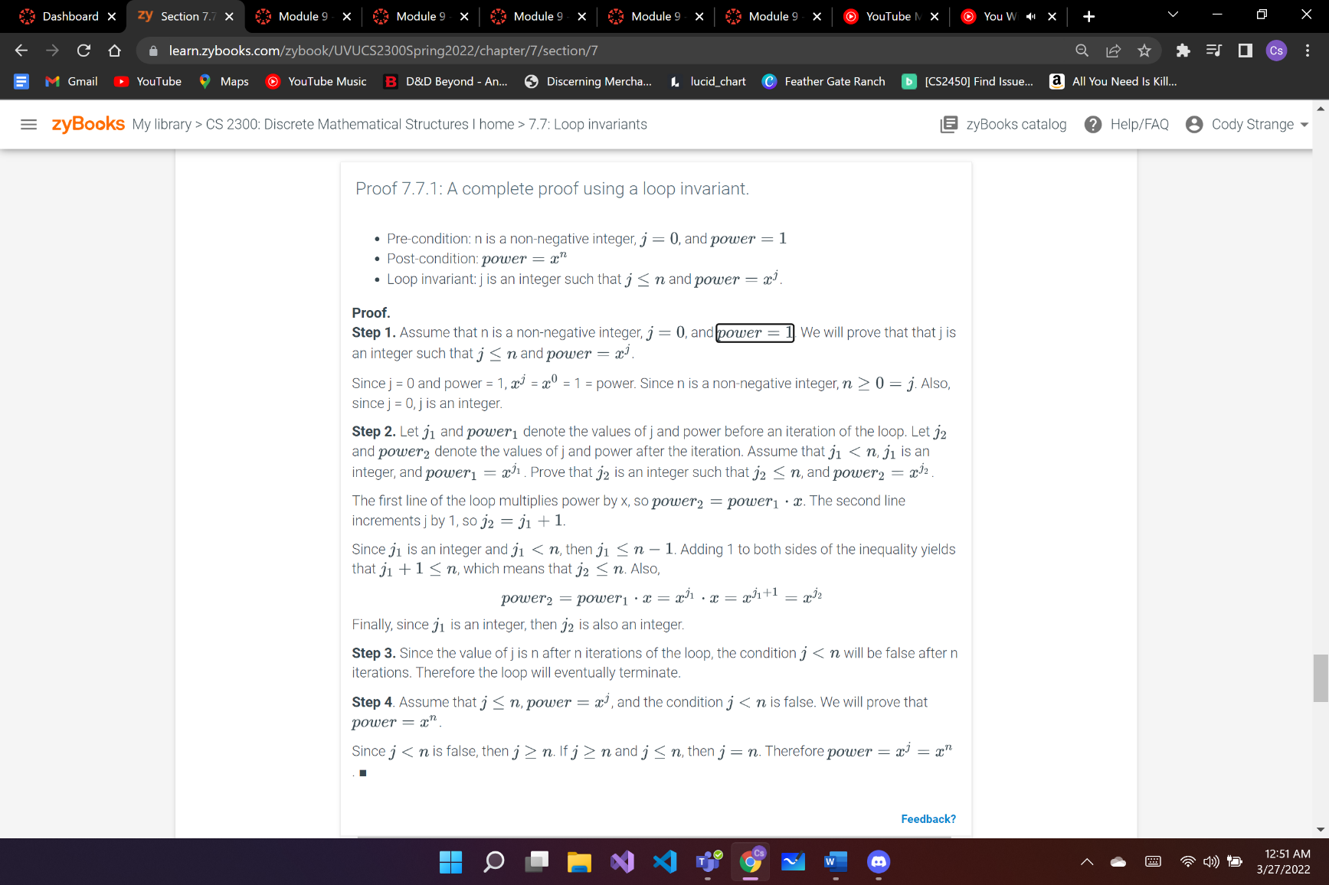

Proof 7.6.1: Upper bound for Fibonacci numbers proven using strong induction

